

**Hands-On with the Modern Data Stack: Labs**

**Hands-on Workshop**

|  |  |
| --- | --- |
| Authors | David Millman, Fivetran |
| Version | 2.0 |
| Date | Sep 26, 2023 |
| Description | This Hands On Lab guides the student through the initial configuration and setup of all the labs that will be performed today.  This latest version adds the known common values, so that labs should be shorter |

# 

**Overview 3**

Prerequisites 3

Agenda 3

What you’ll learn 3

What you’ll need 3

What you'll Build 4

Using this Lab Guide 4

Parameters for labs 4

Personalizing the Lab Guide for your lab 4

**Lab 4 - LDP 6**

4.1 Create Database Schema 6

4.2 Login to LDP and Initial Navigation 7

4.3 Configure a Snowflake Destination 16

4.4. Create a New Channel and Load the Data 23

4.5 Compare and Repair 32

4.5.1 - Ensure the Initial Load is Correct 32

4.5.2 Review Data in Database, Delete and Repair 37

**APPENDIX - A - Lab 0 Files 47**

Table2.csv 47

Table3.csv 48

Table4.csv 48

# 

# Overview

This hands-on workshop will guide you through how to load an initial set of CSV files from an S3 bucket. The main goal of this lab is to achieve a simple goal, load data into Snowflake, while familiarizing the student with the lab setup.

Fivetran provides fully managed and fully automated connectors that help create data movement pipelines that automatically extract and load data from various sources. These pipelines continuously ingest and update data in the cloud destination and enable organizations to focus on their use cases for data engineering, data science, machine learning, and business intelligence.

## Prerequisites

**Nothing** is required prior to the hands-on workshop. During the workshop, you will use:

* Snowflake Account(s) Configured: the student will be given credentials to access a Snowflake account, to read the data
* Fivetran partner account: Each partner is assigned a Fivetran partner account, everyone at that partner is eligible to use this account for training.
* Snowflake Destination Setup: each partner account will have one or more configured destinations setup that will be used
* Credential Spreadsheet: a spreadsheet is configured with a unique set of names/credentials that can be used to fill out the forms and other.

## Agenda

* Quick overview of how to load CSV files from a S3 bucket
* Review of a simple connection from S3 to Snowflake
* Review of the architecture used
* Review of the data and associated metadata placed in Snowflake

## What you’ll learn

* How you can use Fivetran’s fully managed connectors to connect to 100s of sources
* How to quickly and easily create fully automated and fully managed data pipelines

## What you’ll need

* Laptop
* Internet connection with the ability to connect to AWS and Google services in the USA
* Access to the Spreadsheet of lab attendees/usernames and passwords
* 100 Fivetran Facts (Help guide for the tests :) )

## What you'll Build

* PostgreSQL Source (relational database) to Snowflake data pipeline using Fivetran for both historical sync and incremental CDC
* Queries, dashboards, and visualizations using Snowflake Snowsight

## Using this Lab Guide

This lab guide is used in conjunction with a lab spreadsheet that has unique values for each student. They can be read during the labs, or students can spend a couple of minutes replacing values in the lab document so the exercise becomes quicker.

### Parameters for labs

Many of the values for the labs are found in the associated spreadsheet, such as schema specific names. Open the lab specific spreadsheet and find your name, in this example the attendees name is David Millman found in **[CELL-C]** and **[CELL-D]**, then validate that the correct email address is in **[CELL-E]** for the same row.

**\*\*\*If you cannot find your name and/or the email address is wrong, please let the instructor know immediately.\*\*\***

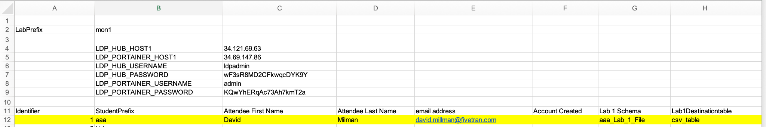

Within the labs, there will be instructions to input the value of **[CELL-G]**, the **[- ]** denote a variable value is required and **CELL-G** denotes the column on your specific row to retrieve the value. In this case the value **aaa-Lab_1_File** is copied from the spreadsheet to Fivetran.

To make this easier, it is recommended to select the row at the beginning of the lab and use the highlight formatting to distinguish ALL the unique values for you during the lab.

### Personalizing the Lab Guide for your lab

For the table below place in the Value column the value of your unique row. The first row

|  |  |  |
| --- | --- | --- |
| **Spreadsheet Cell/Description** | **Search Term** | **Value** |
| **ZZ - Test Value** | **[CELL-ZZ]** | **TestValue** |
| K - Lab Database Name | [CELL-K] |  |
| L- Worksheet Name | [CELL-L] |  |
| AJ - LDP Destination | [CELL-AJ] |  |
| AQ - LDP Target Schema | [CELL-AQ] |  |

Then for each cell value in Word perform Find and Replace, in this example, taken from the first row of the previous table, **[CELL-ZZ]** will be replaced with **TestValue** throughout the whole document by selecting **‘Replace All’**.

Repeat this step for each line in the table.

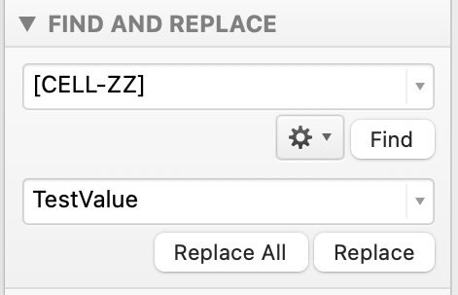

# 

# Lab 4 - LDP

In this lab you will learn the following:

* 4.1 Create Database Schema - create a specific schema in the database that Fivetran Local Data Processing (LDP) will use to add the tables and data to
* 4.2 Login to LDP and Initial Navigation - login to LDP hosted in the cloud and navigate existing configuration, i.e. the different sources that are configured
* 4.3 Configure a Snowflake Destination
* 4.4. Create a New Channel and Load the Data
* 4.5 Compare and Repair

## 4.1 Create Database Schema

One difference between Fivetran.com/SaaS offering and Local Data Processing is that the target database schema is NOT created for you. At this point it is necessary to create the schema in the target schema (Cell K) is the default value

1. Login to Snowflake
2. Select the **Data - Databases - Database Name [CELL-K]** as shown in the following screenshot

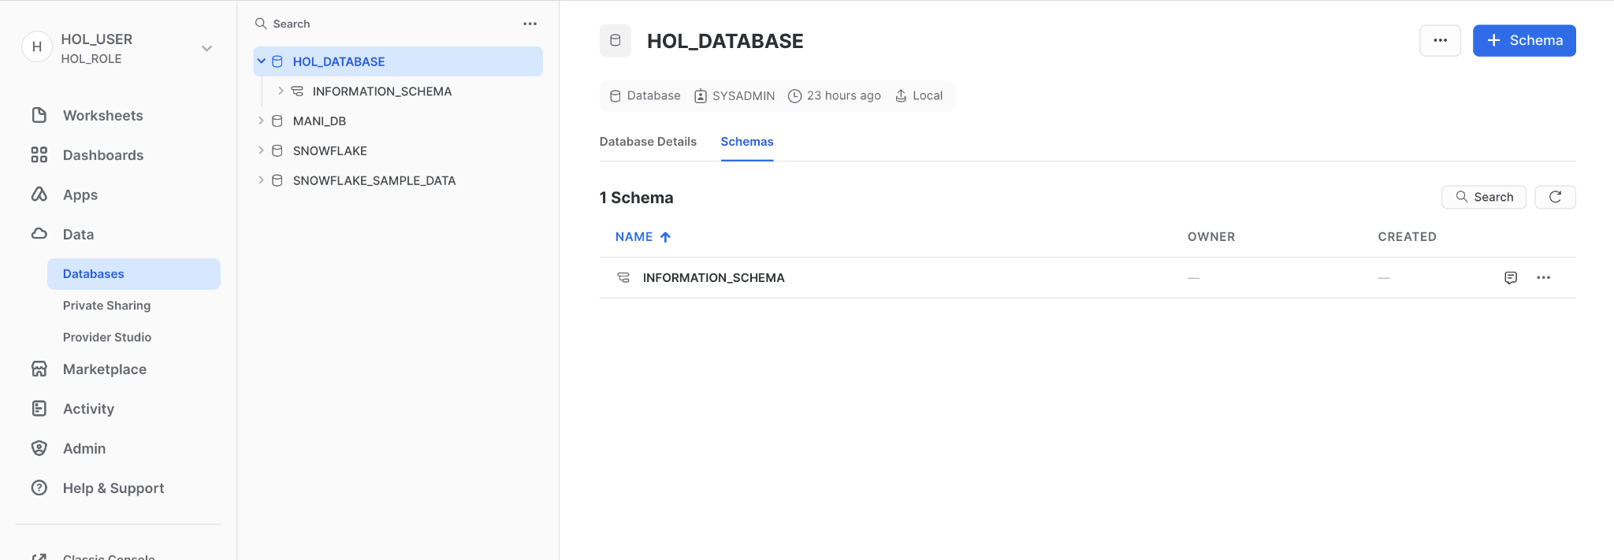

1. Press the +Schema  button within database, at the top right of the page
2. In the dialog box that appears, enter the name **[CELL-AQ]** of the schema (NOTE this is unique to you). The comment is optional and not necessary for this use-case.

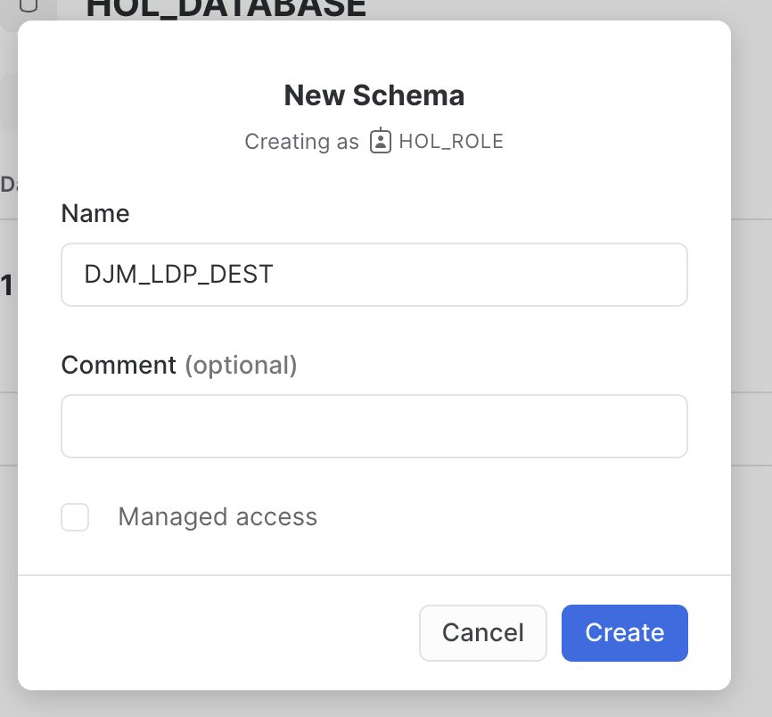

1. When the schema has been created it will be displayed in the designated database, as shown next. When successfully created, you are ready to create the set

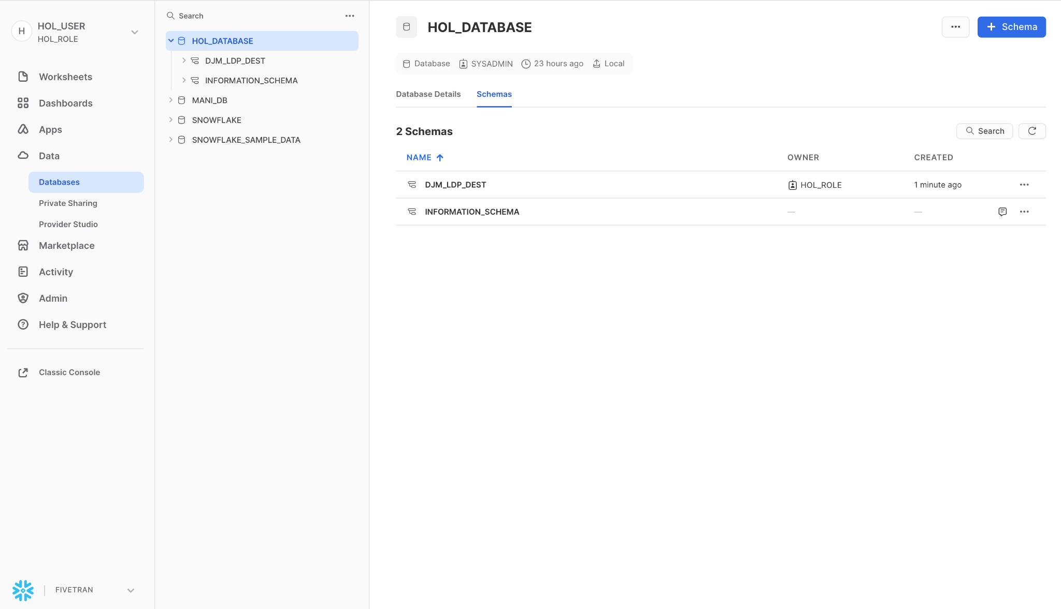

## 4.2 Login to LDP and Initial Navigation

An instance of LDP is being hosted within an Google Cloud instance, where multiple attendees are going to login and work concurrently.

1. Type in the LDP hostname and port in a supported browser **[CELL-AK]**
2. When the LDP login screen is shown (see next screenshot) enter the following:
   1. Username - **ldpadmin**
   2. Password is found **wF3sR8MD2CFkwqcDYK9Y**

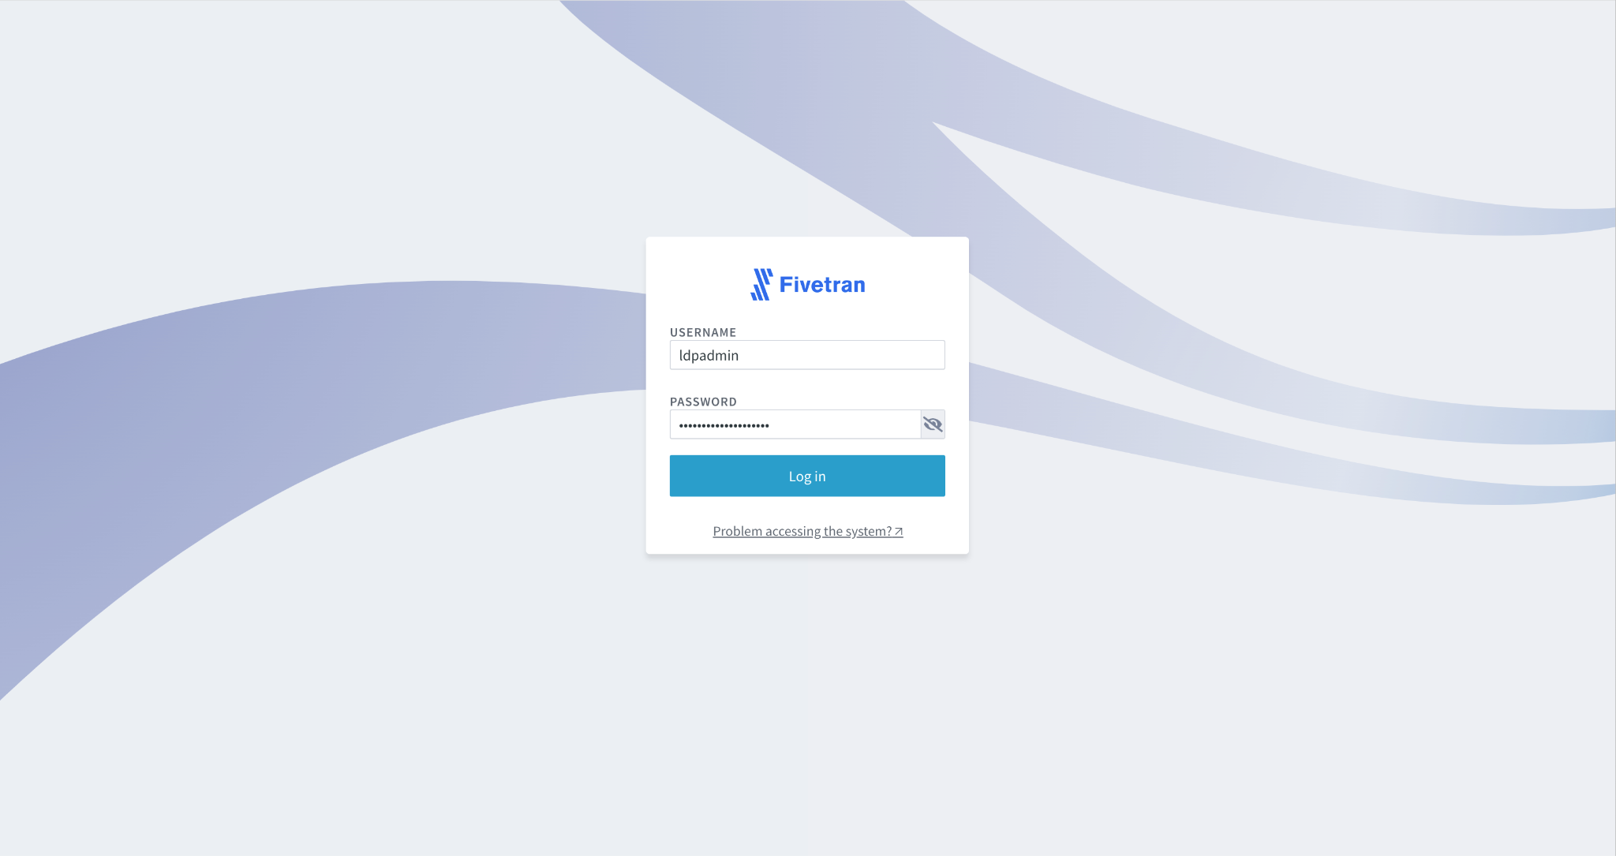

1. On successful login, you may be shown the following:

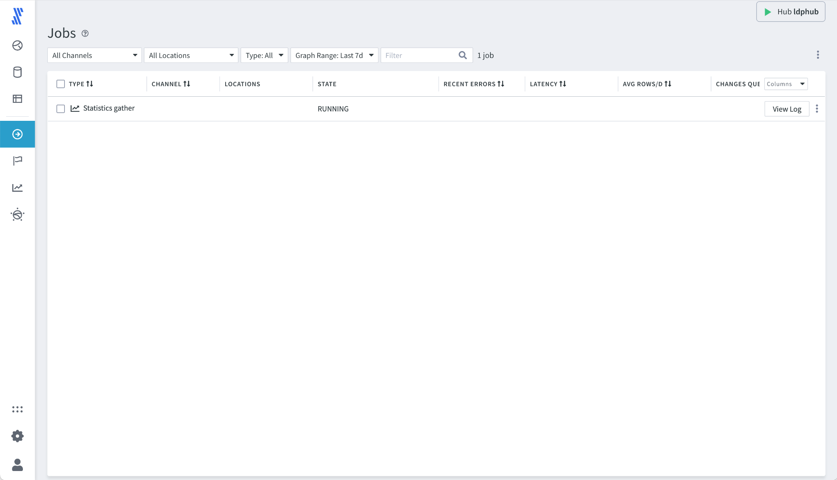

1. Select the Channels  logo on the left navbar. At this point all the channels (Pipelines from Source to Destination) are shown and listed. If no channels currently exist the following screen will be displayed. There is an option to build the channel from scratch, but we will use another route in this lab.

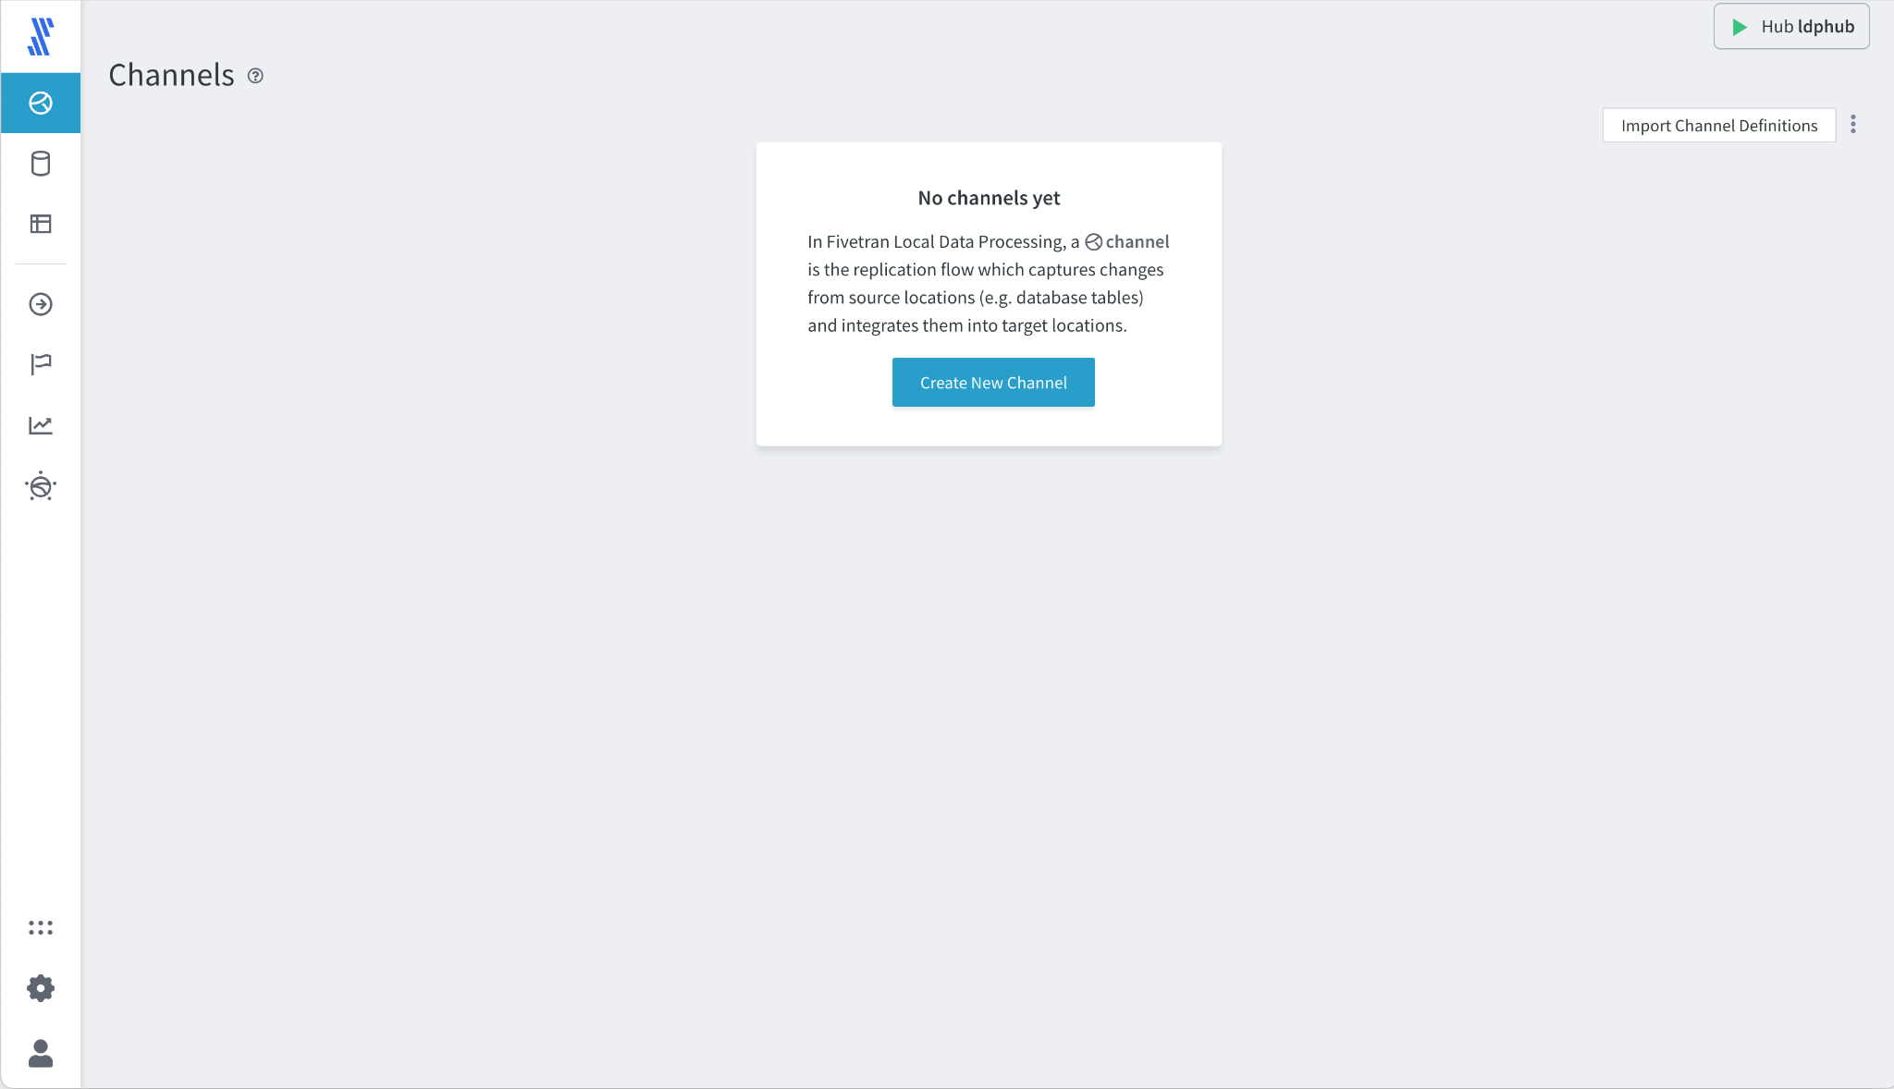

1. Navigate to Locations (the second icon in the navbar) and a list of predefined connections will be displayed, as shown.
2. For this exercise SQL Server will be used as the source and should be listed in the available connections.
3. Note that other connections may be available and configured for you to review, but are not documented or used as part of this lab.

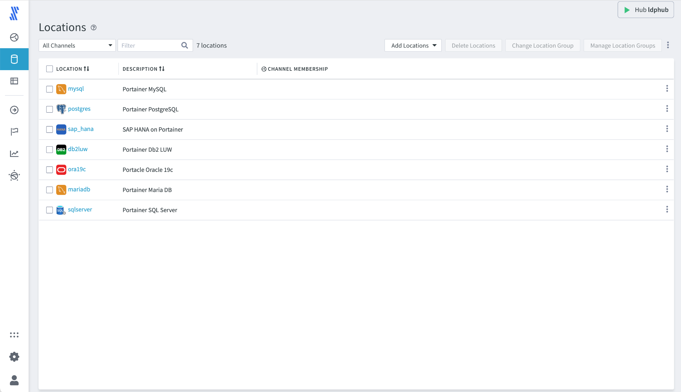

1. Select the SQL Server connection, 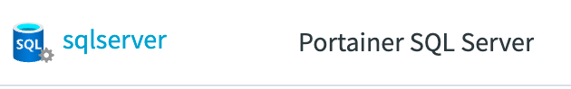 displays the following screen. There are four main areas, that will be explored as part of this :
   1. **Agent** - this is the deployment of the agent and its configuration, relative to the LDP hub and the database.
   2. **Database Connection** - is the connection used to perform a historic load from the specified database, using a SELECT statement from the selected tables.
   3. **Source and Target Properties** - as this is a database source, this is the configuration on how LDP will capture ongoing changes from the database, i.e. the Change Data Capture (CDC) definition
   4. **Channel Membership** - a connection can be a member of multiple channels. If this is true all the channels using this connection are listed here..

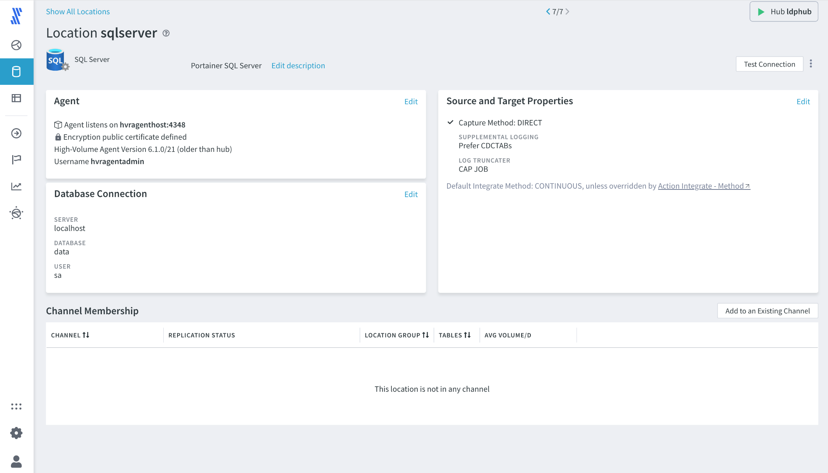

1. **Test Connection** - the primary function to test is whether the connection is live. This can be performed by clicking the ‘Test Connection’ button at the top right hand corner of the screen. If successful a green status bar will be displayed a the top of the screen stating
   1. ‘Connect Succeeded for this location’
   2. **If another message is displayed, please raise your hand and let the instructor know.**

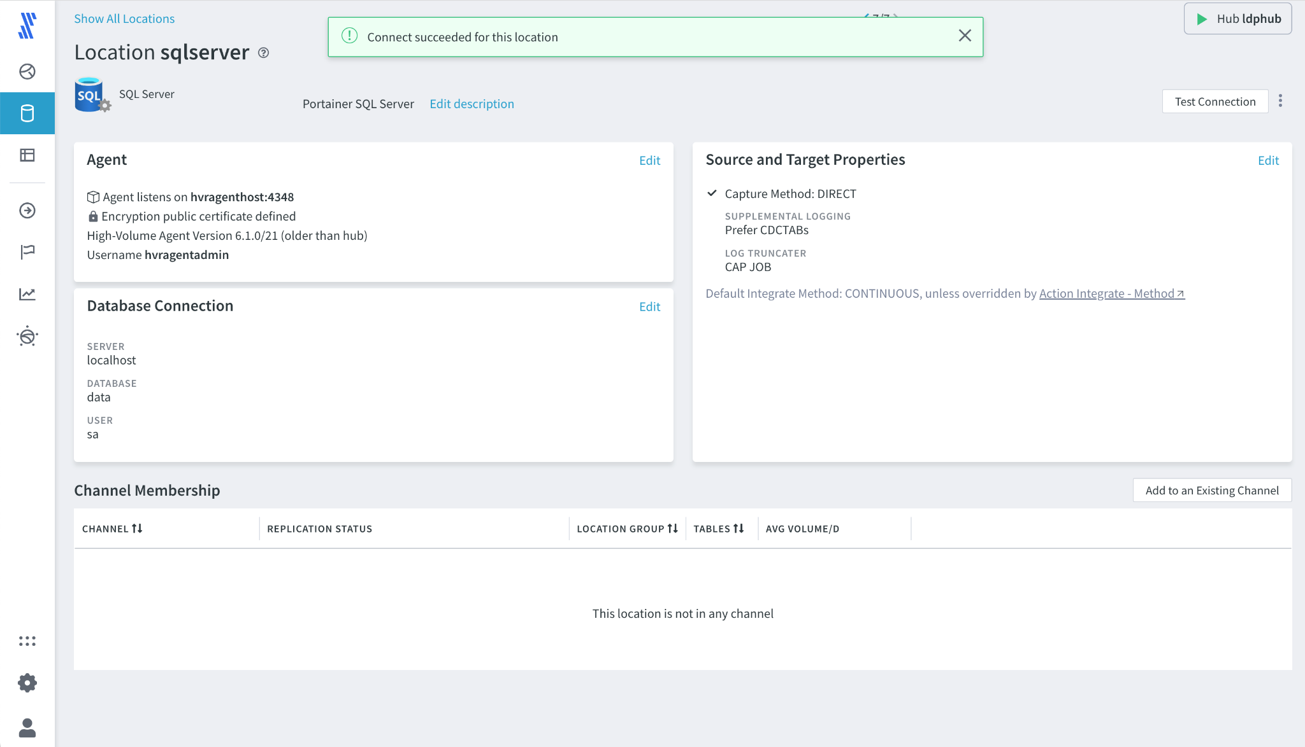

1. **Connection Review - Agent** - An agent has been installed on the same machine as the source database, on the host **hvragenthost**. The agent is listening on port **4348** for a connection from the LDP Hub and a certificate is being used to ensure the agent and hub combination is correct. All of this has been preconfigured for this lab, but would be required to be set up on an initial setup.
2. Note that the Agent Connection will be tested, as this screen is exited due to the ‘**Test connection before saving**’ being selected. To exit this screen select **Cancel**.

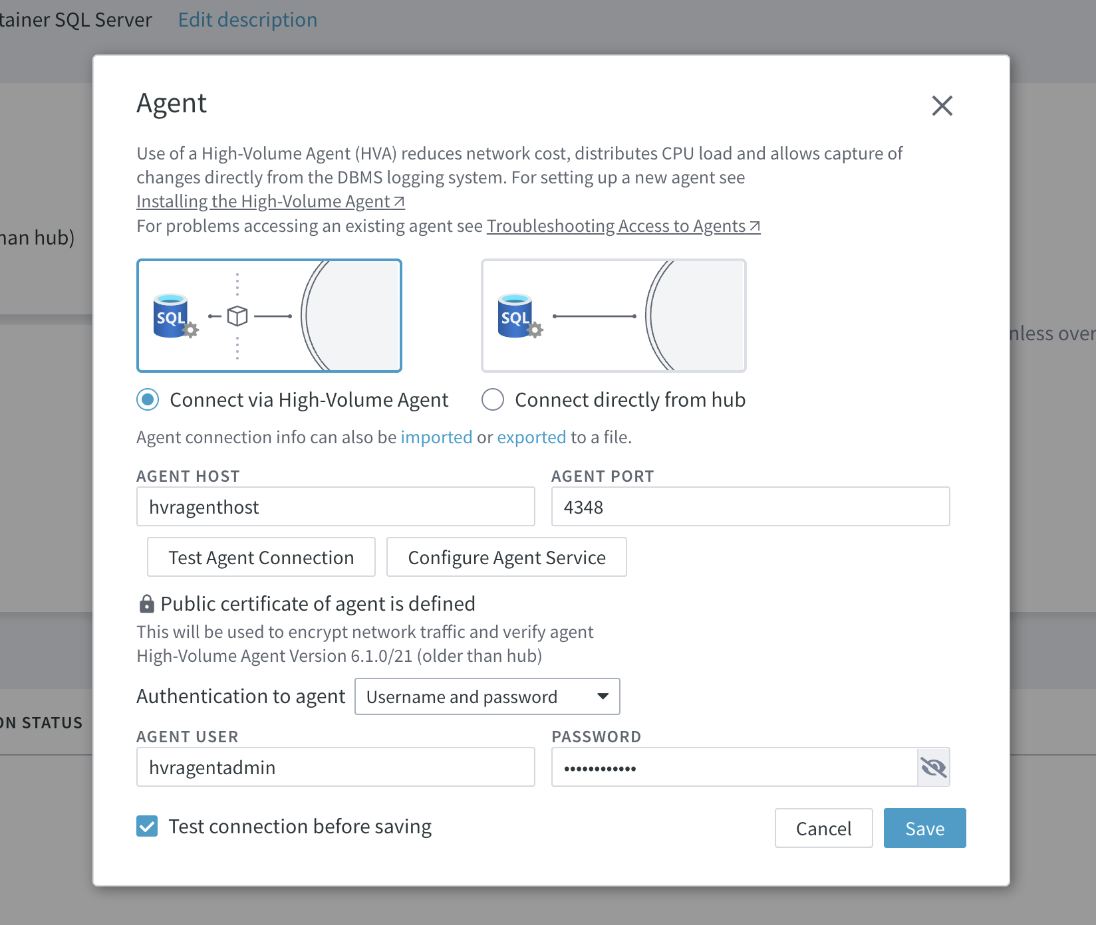

1. **Database Connection** - returning back to the SQL Server connection screen, move the cursor to the **Database Connection** area and select **Edit**.



1. The ‘Database Connection’ configuration dialog is shown. This dialog shows the parameters for the database connection for which the agent will connect. The following has to be specified:
   1. **Server** - this is the hostname, or the IP Address where the database server is running. In this example as the agent is installed on the same host as the database server **localhost** can be used.
   2. **Database** - the name of the specific database to connect to
   3. **User -** username for the connection
   4. **Password -** password for the connection
   5. **Advanced Options** - these are shown but not used in the lab and can be used if updated versions of database drivers are being used.
   6. **Test Connection before saving -** again this is selected to ensure that as the connection is navigated everything is working correctly.
2. Press **Cancel** to exit out of this connection

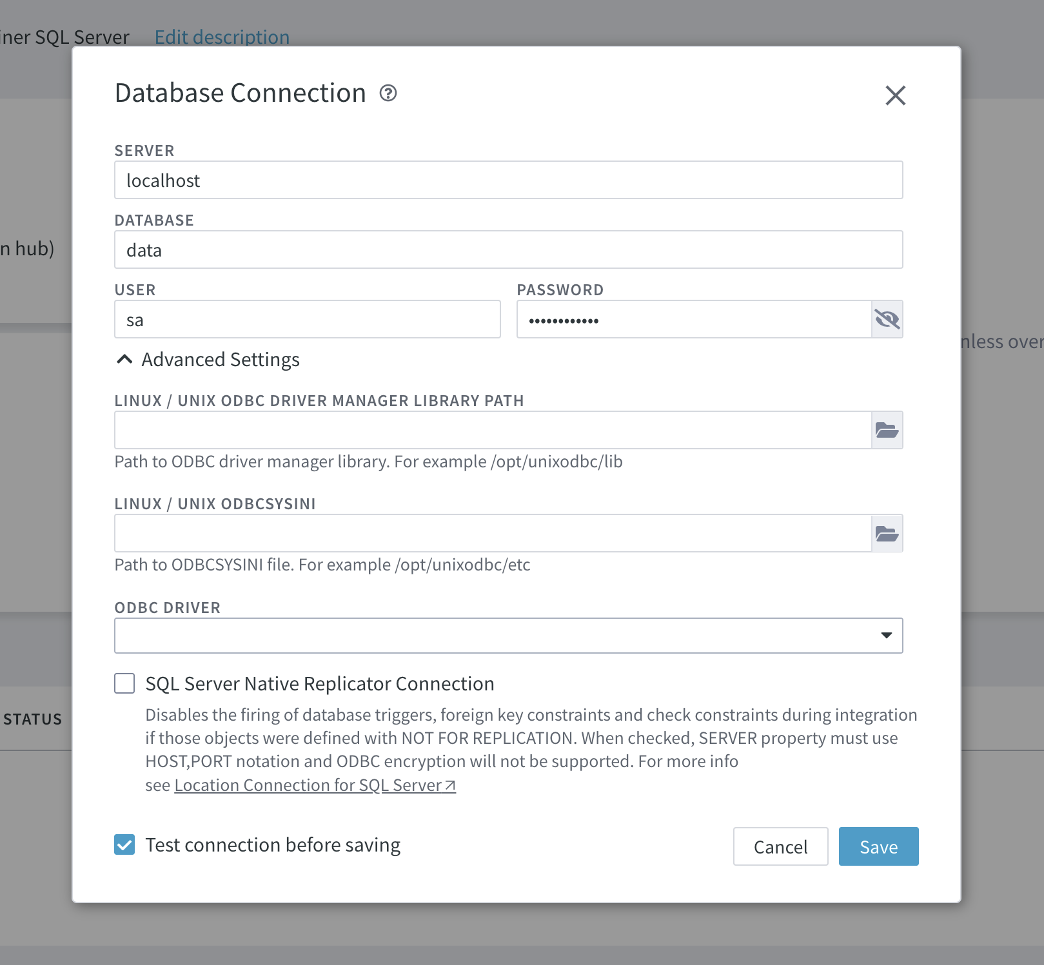

1. The user is returned to the SQL Server connection, on the right hand side of the connection is the Source and Target Properties, select **Edit**



1. **Source and Target Properties** - This dialog defines the CDC process for SQL server as a source. The options are:
   1. **Direct Transaction Log Access** - the agent will read the active database transaction log for all the changes, by looking for new events that are added. These changes will be read directly by the agent and compressed 10-20x before being sent to the LDP Hub.
   2. **Archive Log** - with this option only archive logs will be read. Archive logs are instances of the Direct Transaction Log that have been archived to a specific archive directory.
   3. **SQL Access** - this is where LDP can use SQL based queries on **SQL Server Change Tables** to detect and propagate changes.
   4. **Database Triggers** - it is possible to add specific database triggers to a table to allow capture techniques.

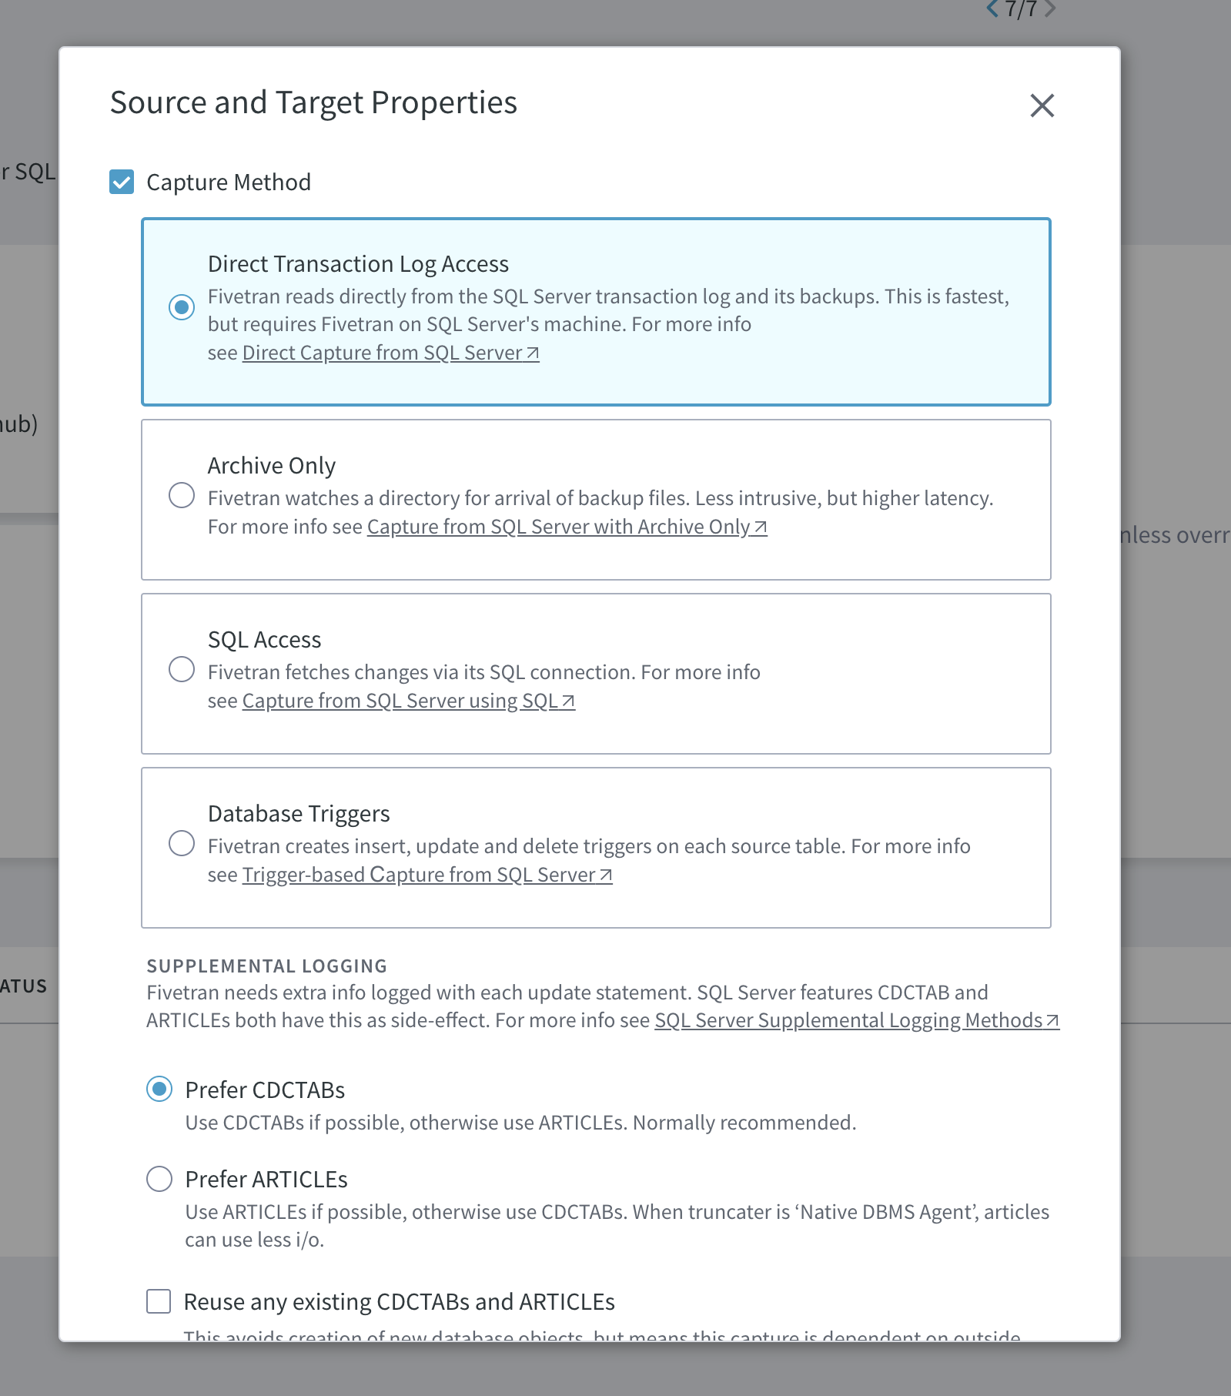

1. The flow of these is most desirable and least impact to the database server, to least desirable and highest impact, when working on real-time transactional databases.
2. Close the **Source and Target Properties Window** by clicking ‘Cancel’ or ‘X’.
3. The user is now guided back to the SQL Server connection overview



## 4.3 Configure a Snowflake Destination

1. Select ‘**Show All Locations’** at the top left of the screen to return to the list of all the defined connections



1. At the top of the screen select the option **Add Locations -> Create New Location** as shown.

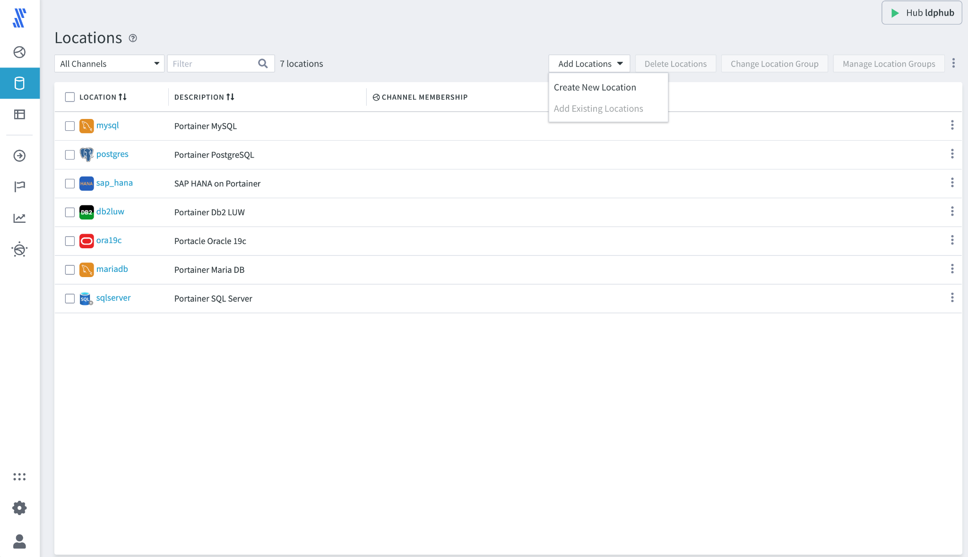

1. The screen is shown with all the possible location types, at this point it is easy to see the full extent of all the types of databases that Fivetran LDP supports as a source and/or target. At this point enter in the following:
   1. **Location Name** - entered in the top left corner, this value must be unique and can extracted from [**CELL-AJ]**
   2. **Description** - this is optional and will typically include a quick overview, any contacts etc for the channel etc. Feel free to enter some text such as your **name/email address** for this lab.
   3. **Destination Type** - the destination for this channel is Snowflake, so select the Snowflake Icon 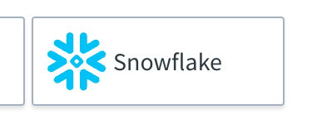 when the Name and Description are complete.

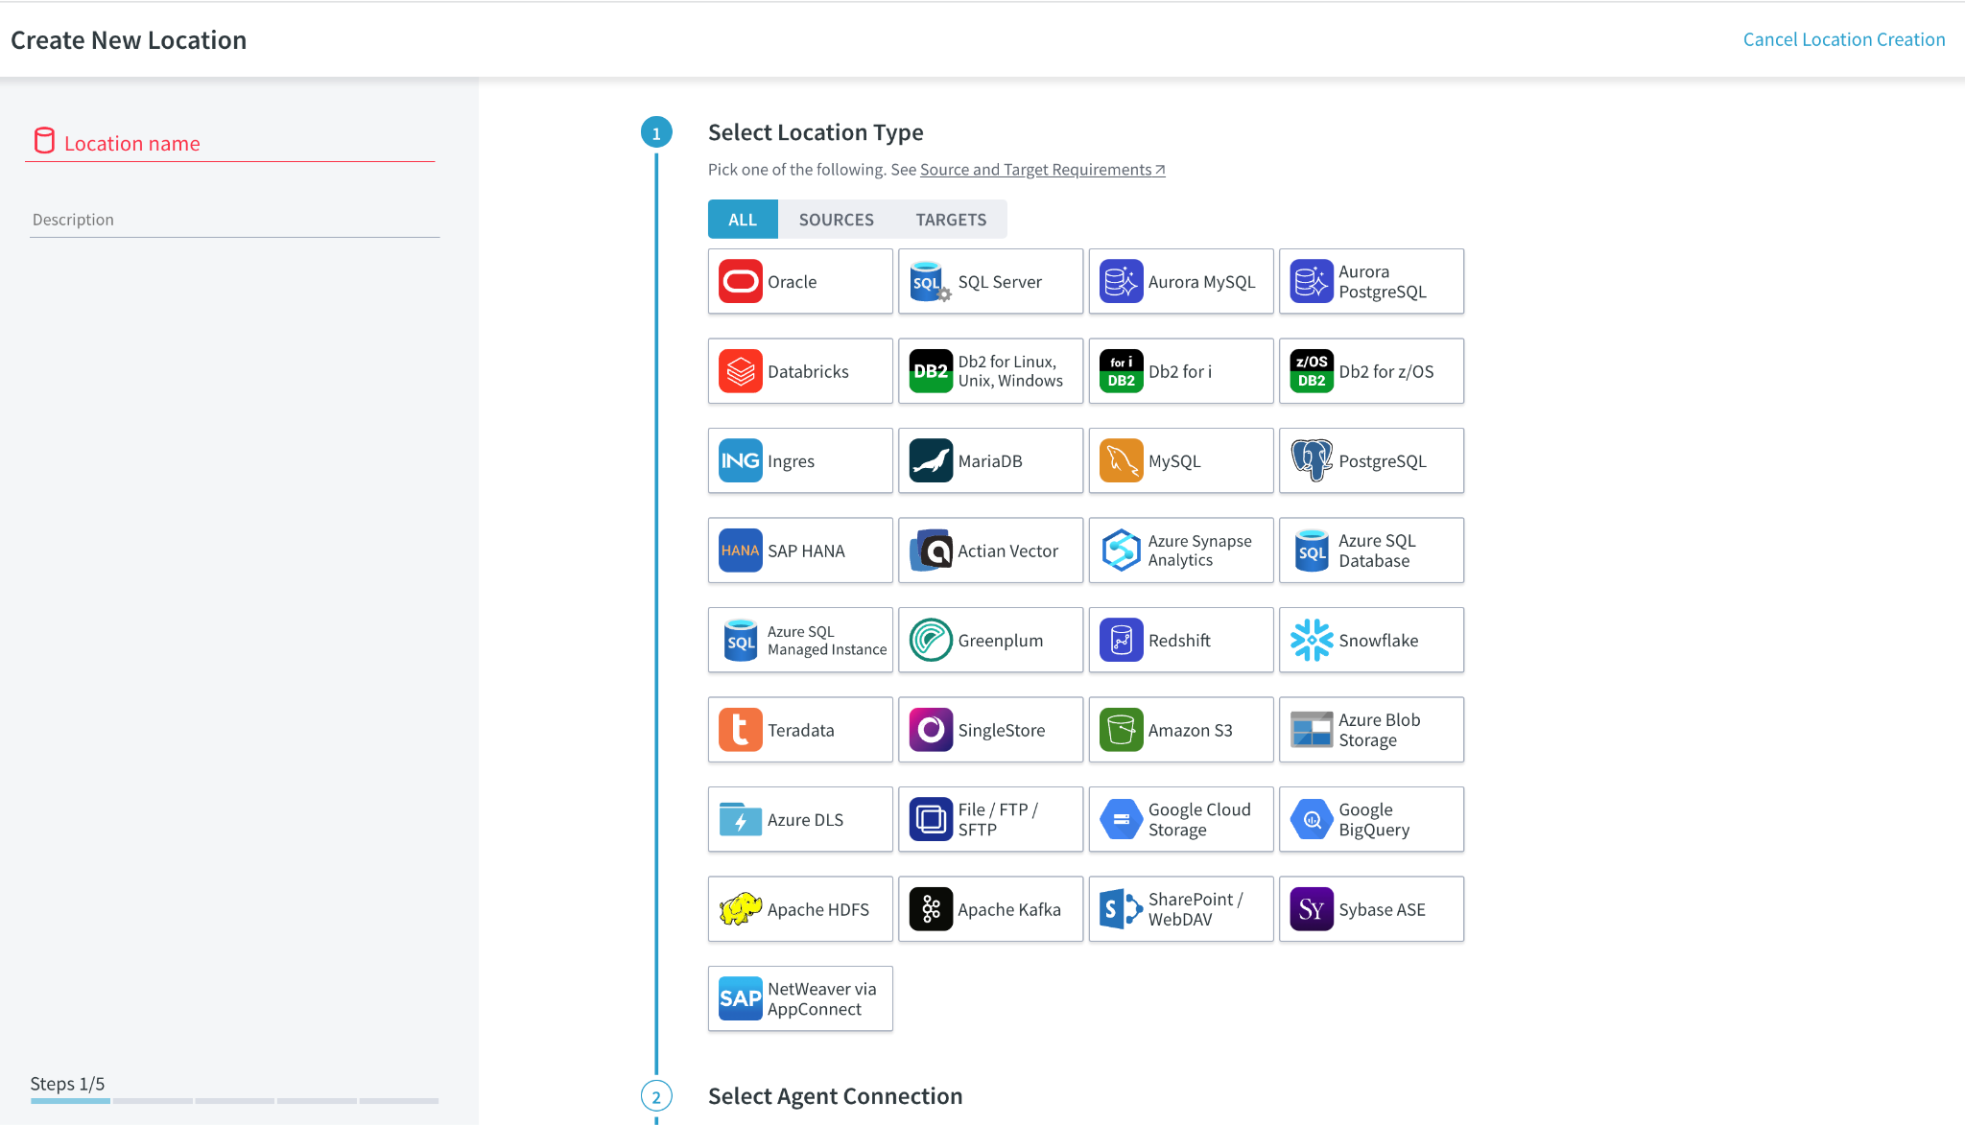

1. The second screen of the connection setup is now displayed. The server is going to connect directly to the Snowflake account to push updates, as this is the case in the **‘Select Agent Connection’** select **‘Connect directly from hub’.** Then press 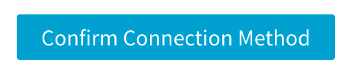

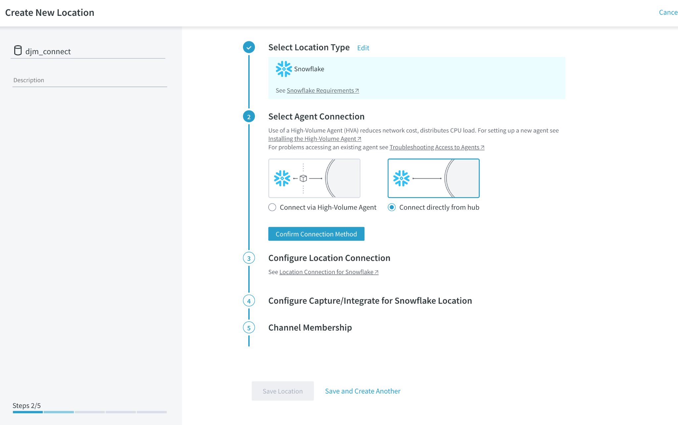

1. Step 3 is now displayed, where the database connection parameters are set to define how the LDP hub will connect to the Snowflake instance

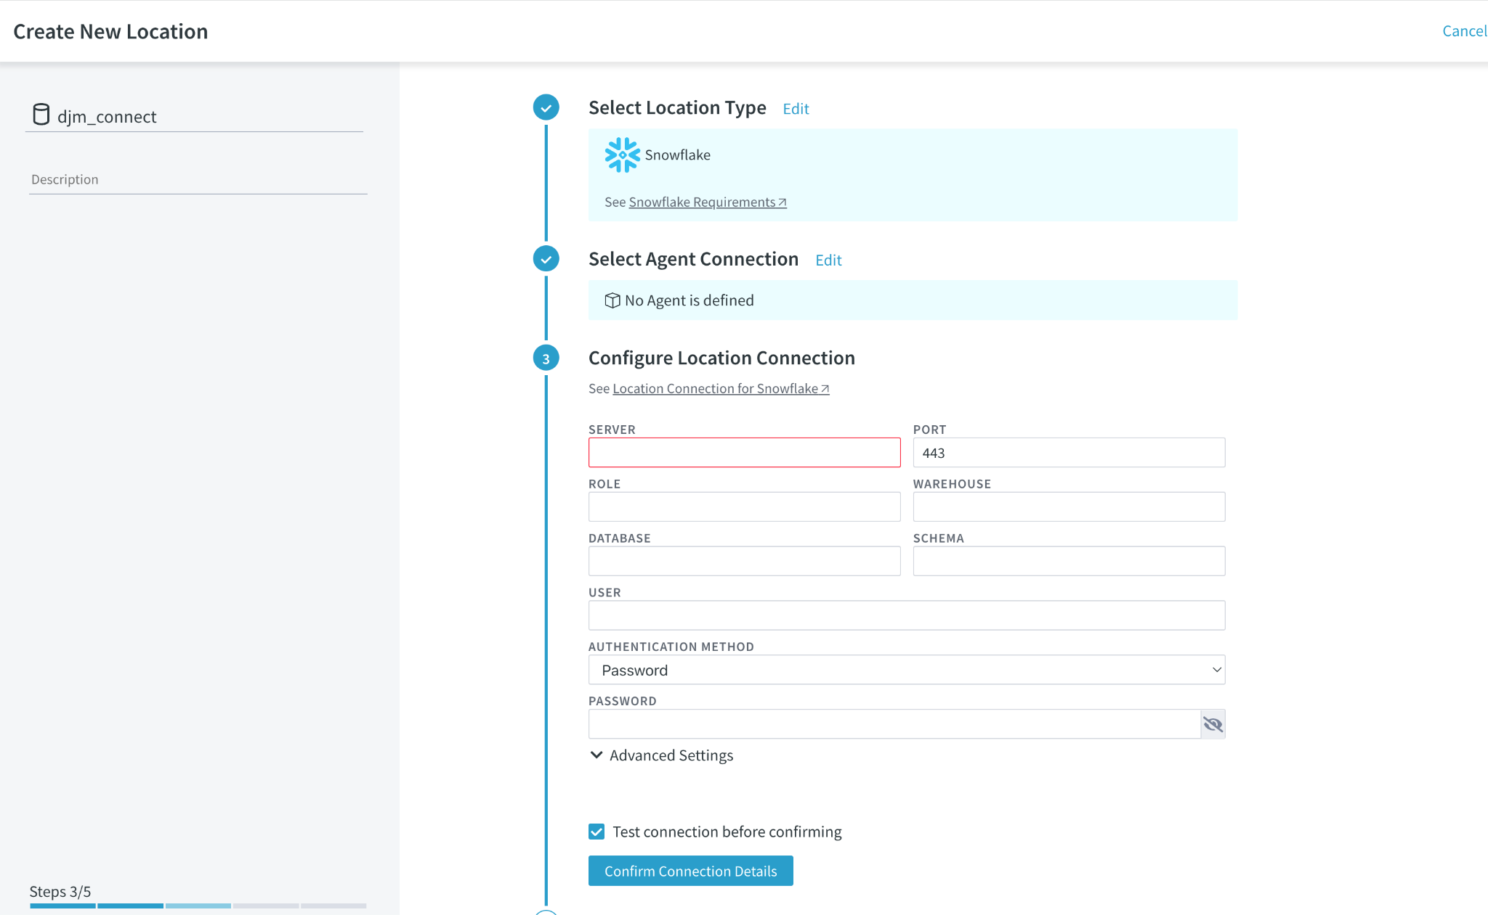

1. The settings for the connection are shown/found here
   1. **Server - fivetran.snowflakecomputing.com**
   2. **PORT -** 443
   3. **ROLE - hol_role**
   4. **WAREHOUSE -hol_warehouse**
   5. **DATABASE - [CELL-K]**
   6. **SCHEMA - [CELL-AQ]**
   7. **USER - hol_user**
   8. **AUTHENTICATION METHOD** - Password
   9. **PASSWORD - gojMjrpwWFzjYeKbVmRw**
   10. **TEST CONNECTION BEFORE CONTINUING - CHECKED**
2. Test the connection and move to the next step by selecting 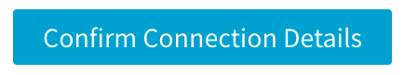

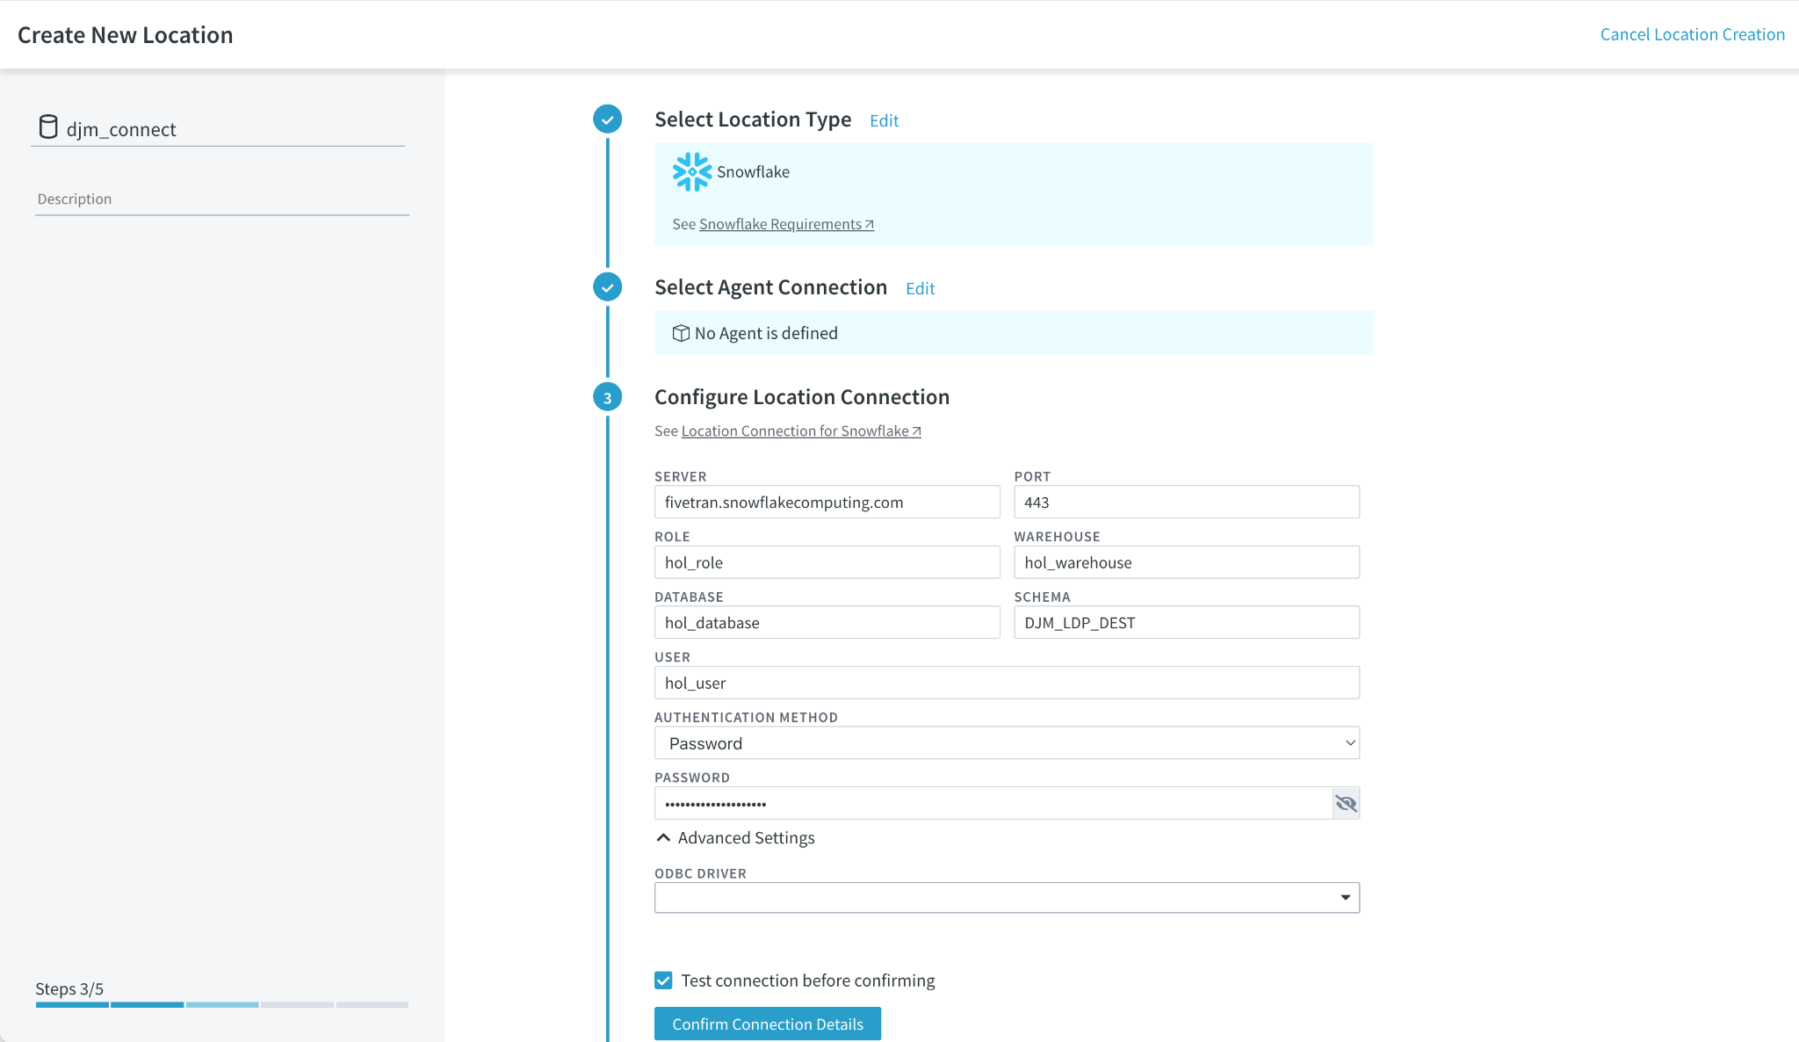

At this point some errors may be observed, such as:

|  |  |
| --- | --- |
| Possible Error Message | Remedy |
|  | In this error, LDP has connected to the Snowflake instance and has authenticated and authorized access. What cannot be found is the Schema, that was created at Step 1 (Please double check the Schema names) |
|  | In this error the credentials used to access the |
|  | In this scenario the user has put in the full URL or similar for the Snowflake instance, ie. <https://fivetran.snowflakecomputing.com>. The HTTPS is NOT needed, just enter fivetran.snowflakecomputing.com or equivalent for the target account |

1. Step 4 specifies certain optimizations that can be performed to push updates, as part of the integration cycle, to the Snowflake database. For this exercise make sure that ALL the options are deselected, as shown in the next screen shot
   1. **Intermediate Directory - DESELECTED**
   2. **Integrate Staging Directory - DESELECTED**
   3. **Case Sensitive Names - DESELECTED**
   4. **Test Connection before confirming is SELECTED**
2. then press 

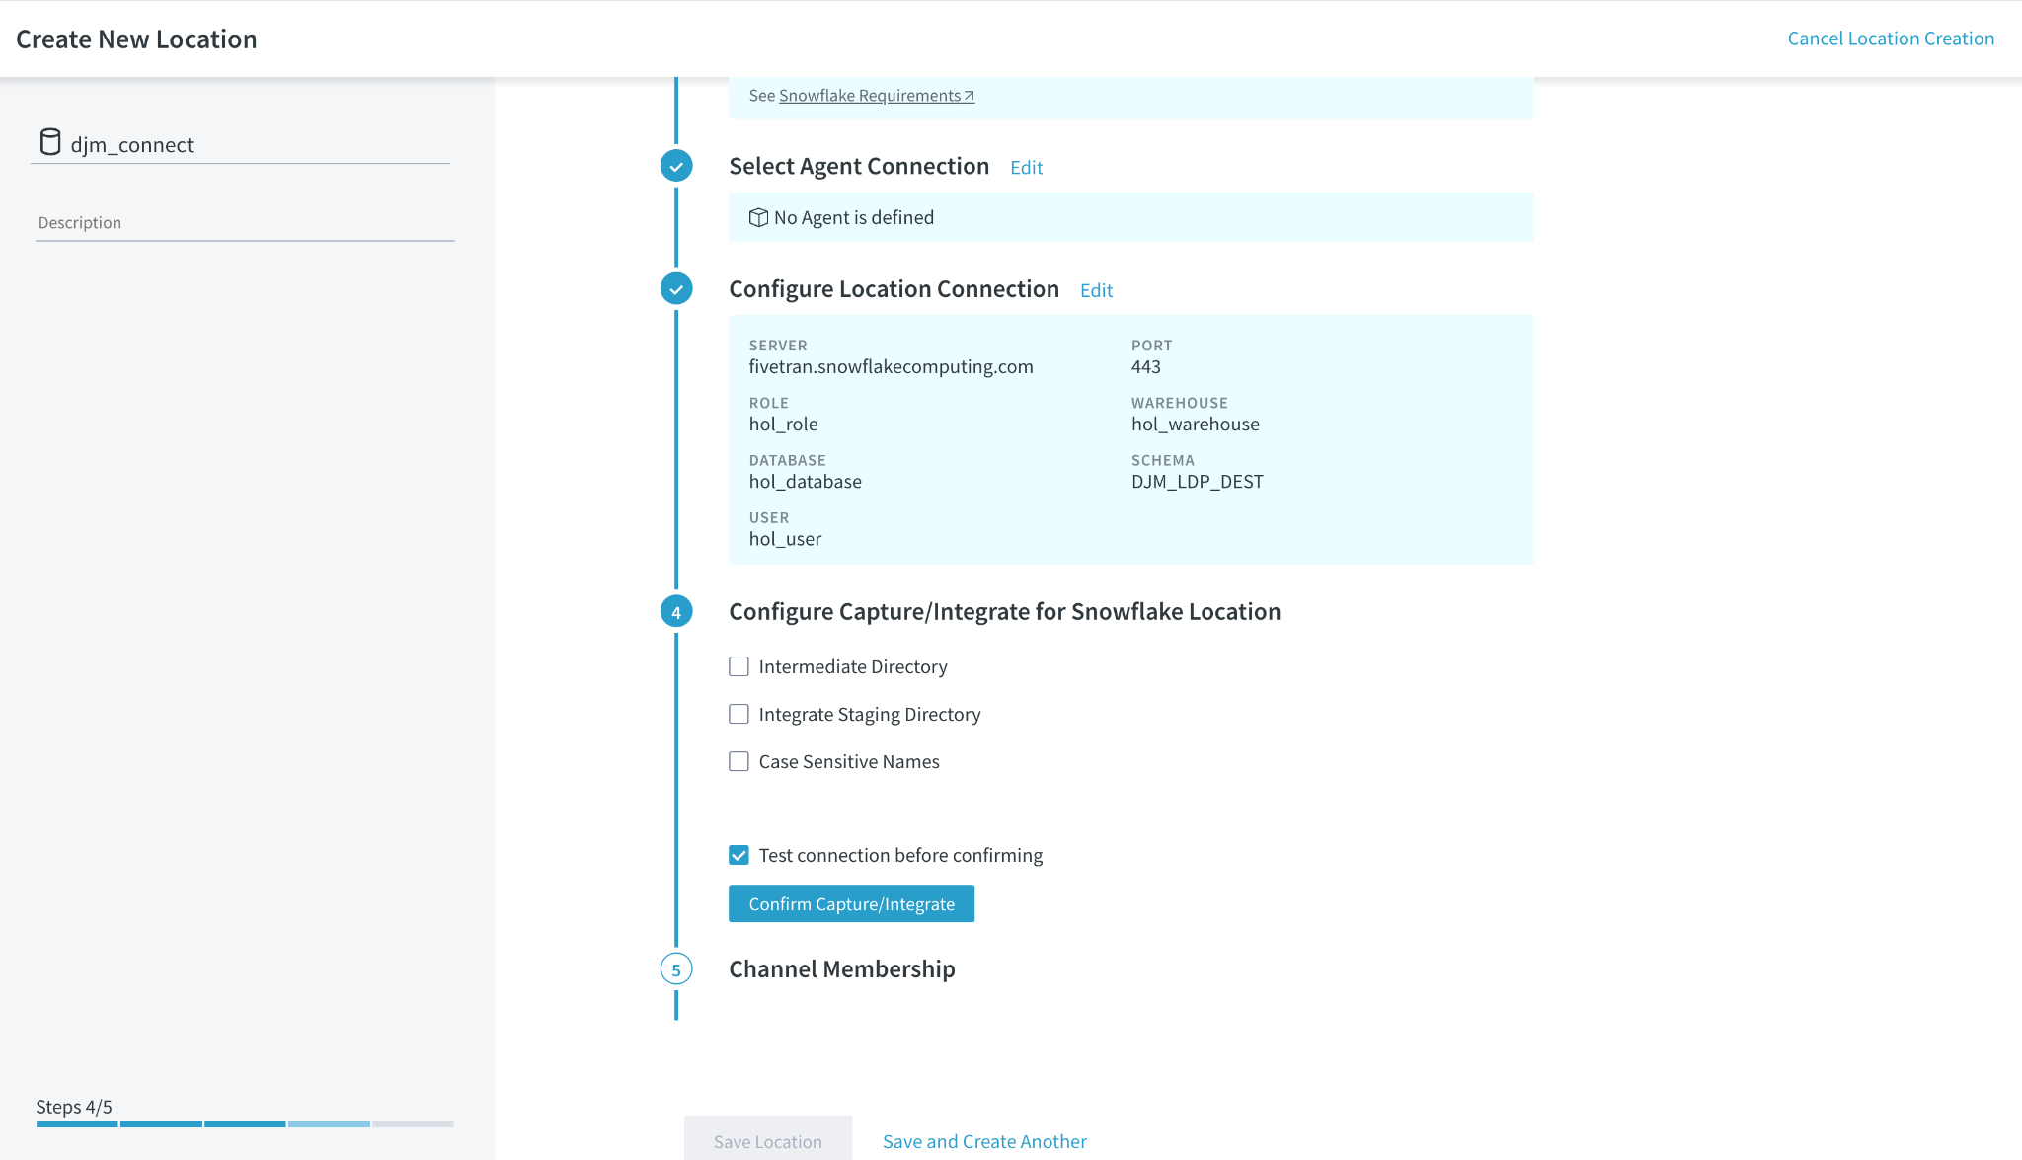

1. Step 5 is to confirm the channels that this connection is part of. As you’ve not created a channel so far, it will not be a member of any channel. Ensure
   1. **Add this Location to a channel**  - is **UNCHECKED**
2. Press 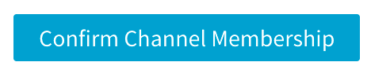

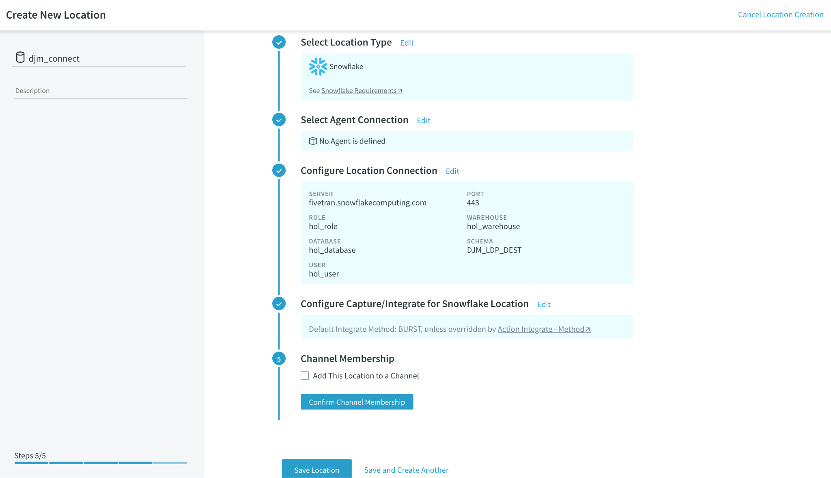

1. Final confirmation of the connection is now confirmed

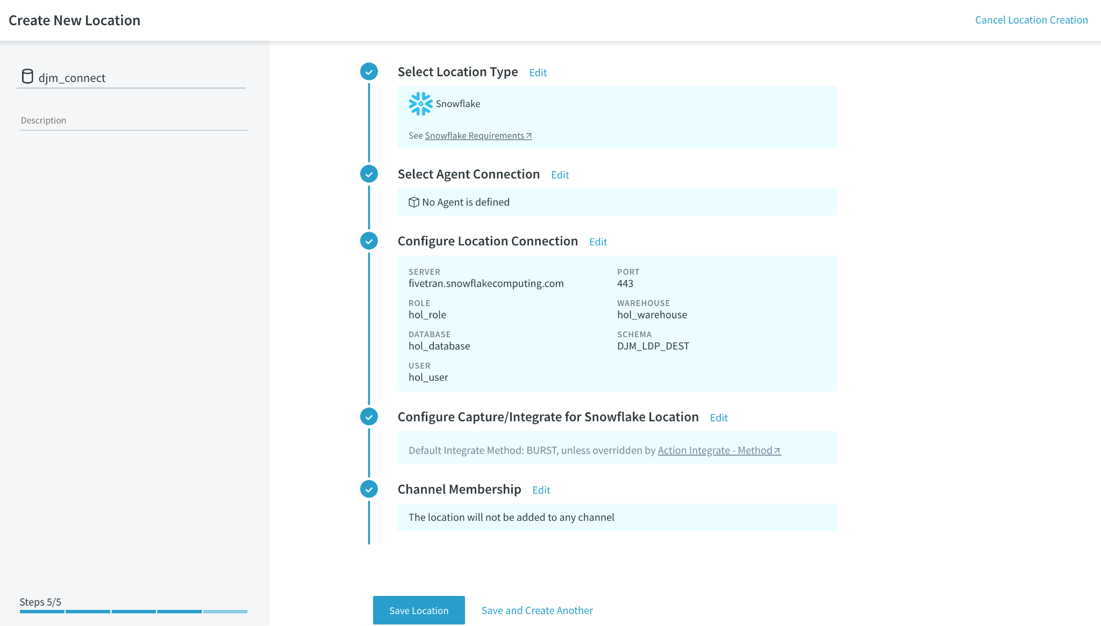

1. Finalize and Save the location by pressing 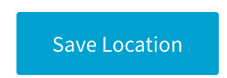
2. You are returned to the list of all the locations. Note as other students are concurrently creating destinations in the same HVR LDP instance, multiple will appear.

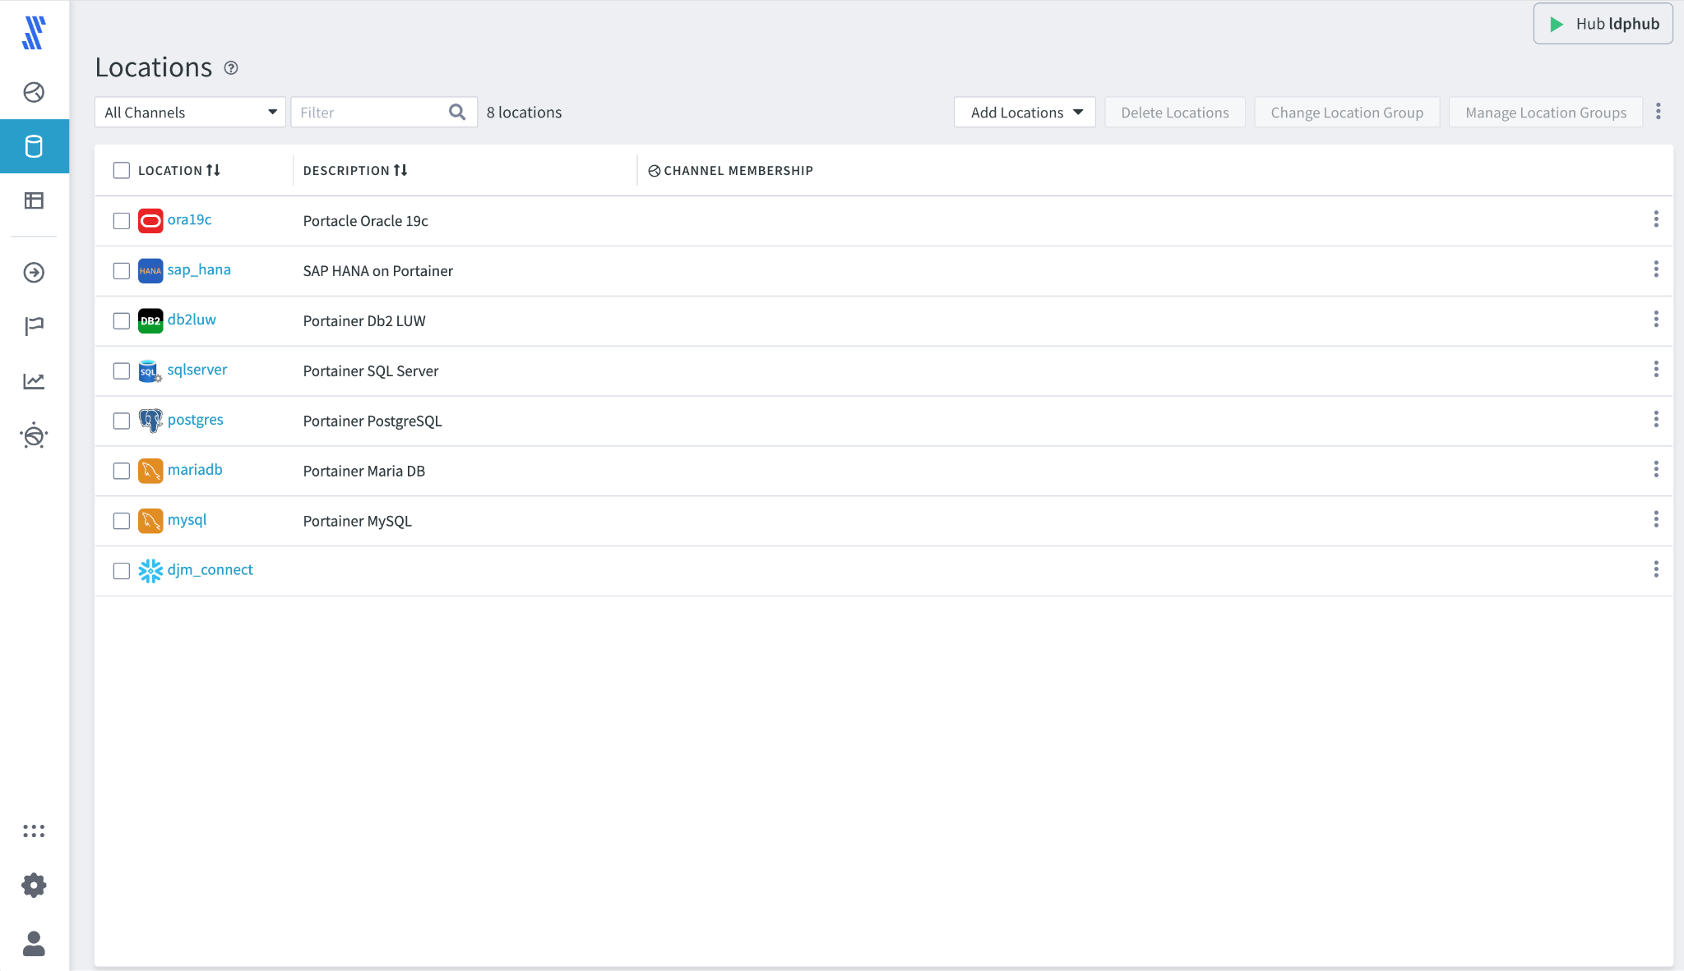

1. LDP provides a search/filtering option to allow you to quickly review the connection just created. At the top of the locations, enter in the initial characters of your location name **[CELL-AJ]** to show the created location.

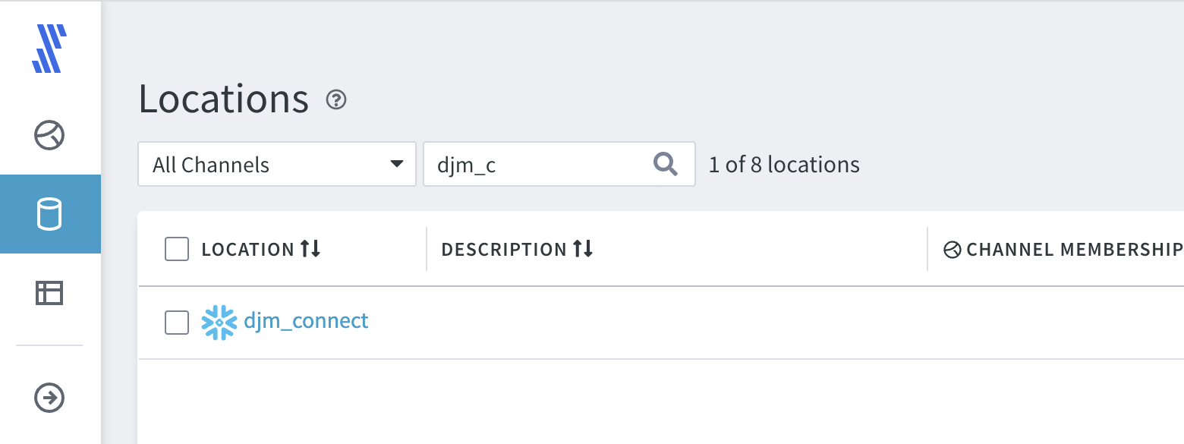

## 4.4. Create a New Channel and Load the Data

We will load data into the new Snowflake schema using the Snowflake target location we just created in 4.3 Configure a Snowflake Destination and using the SQL Server source location already defined and reviewed in 4.2 Login to LDP and Initial Navigation.

The channel will feature a 1-1 connection between source and destination. Configuration of the channel will ensure that the contents of the destination are an EXACT replica of the source. This means that any INSERT/UPSERT/DELETE performed will be replicated, highlighting a functional difference between the database connectors found in Fivetran.com and LDP.

Fivetran.com does not have a 1-1 replication setting. Fivetran.com and LDP do share the ‘soft delete’ and ‘time key’ (append only) replication paradigms. LDP’s ‘standard replica’ model provides the ability to perform full analytics on the replica as if they were happening on the source.

1. Select the Channels  option, on the left navigation bar. if no channels exist the following will be displayed, select 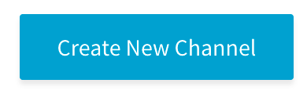

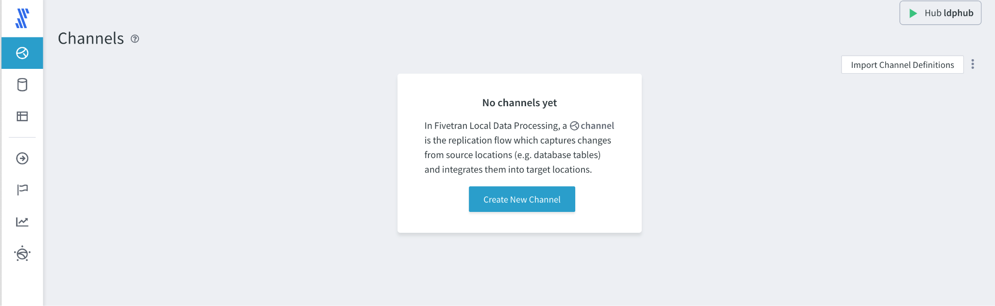

If channels exist, they will be listed as shown, so select 

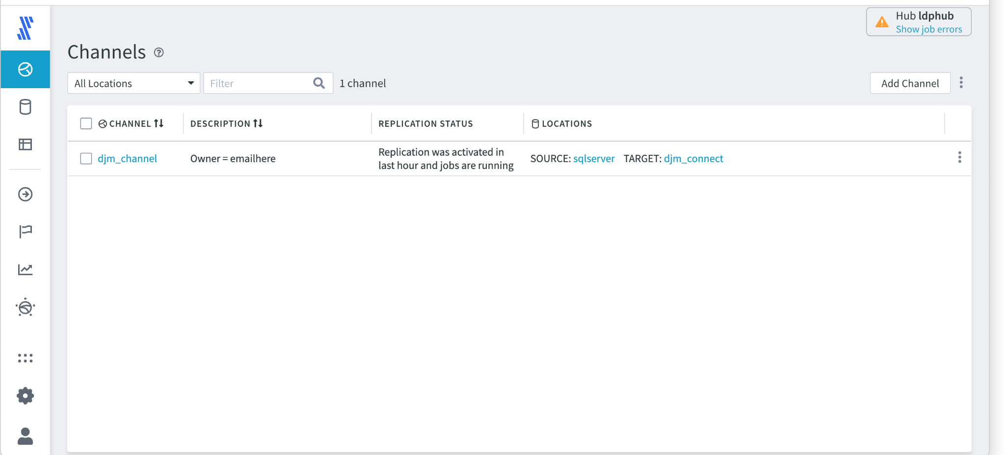

1. Create New Channel, step 1 is shown, enter
   1. **Channel Name - [CELL-AI]**
   2. **Channel Description -** a simple description such as email address etc
2. Select ‘Channel Type’ 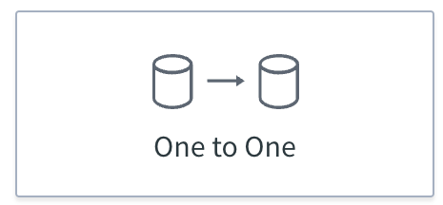. This type of channel is closest to that found in Fivetran.com and is suggested for most use-cases.

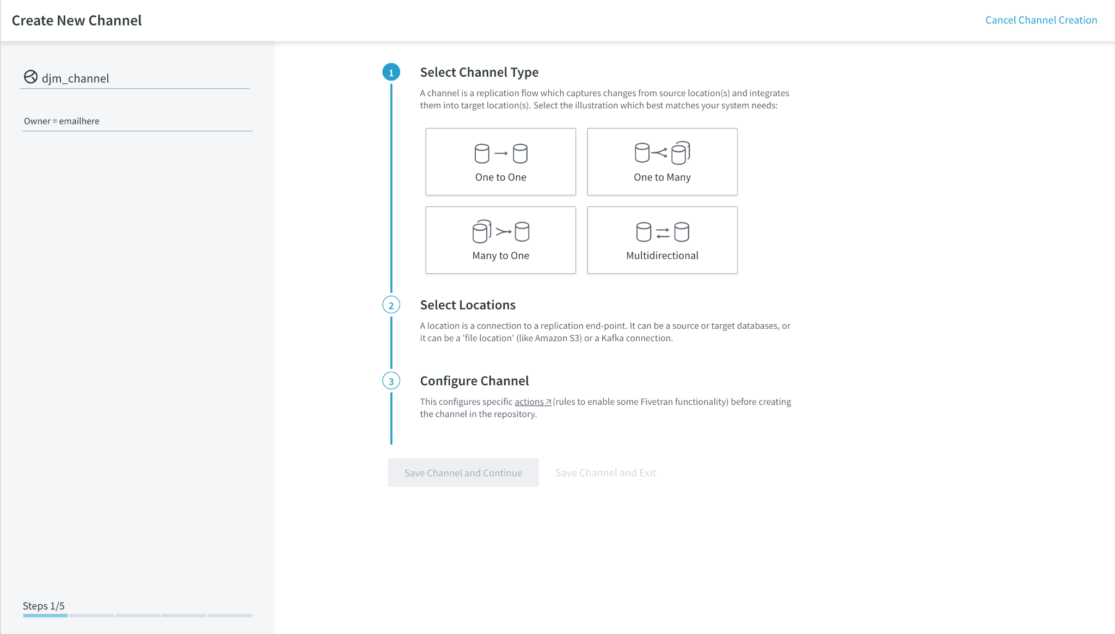

1. With the channel type selected the single source and target locations need to be configured, in this case SQL Server to the Snowflake target just created. For the Source Location, select the ‘**sqlserver’** source.

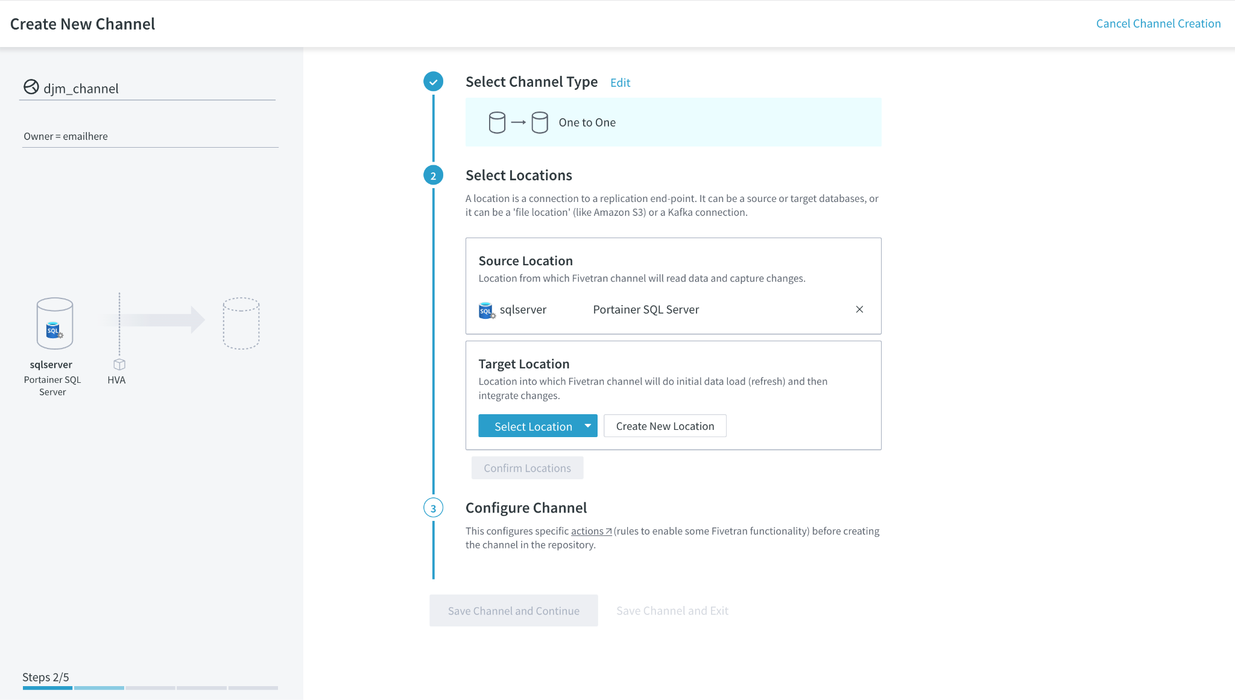

1. For the Target Destination,select your target location as you will see other users’ targets as well. Use the value from **[CELL-AJ].**

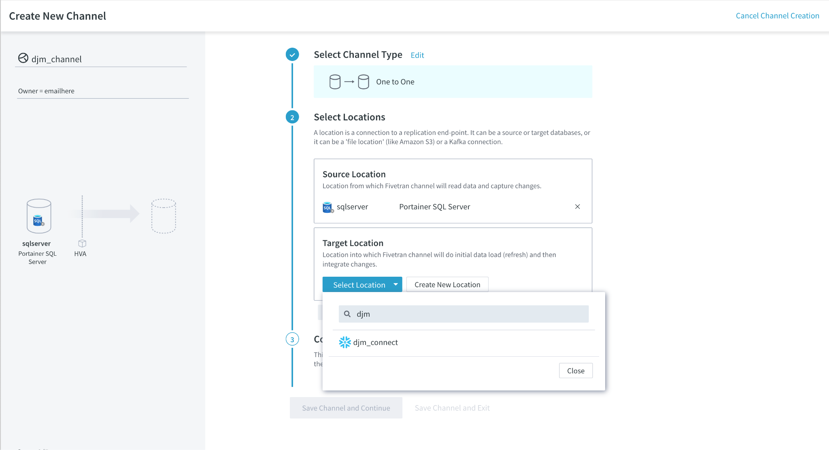

1. Part 3 of the channel setup defines how the data is replicated from the source to destination. Select **Standard Replica** and select 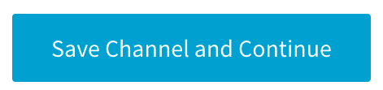to continue

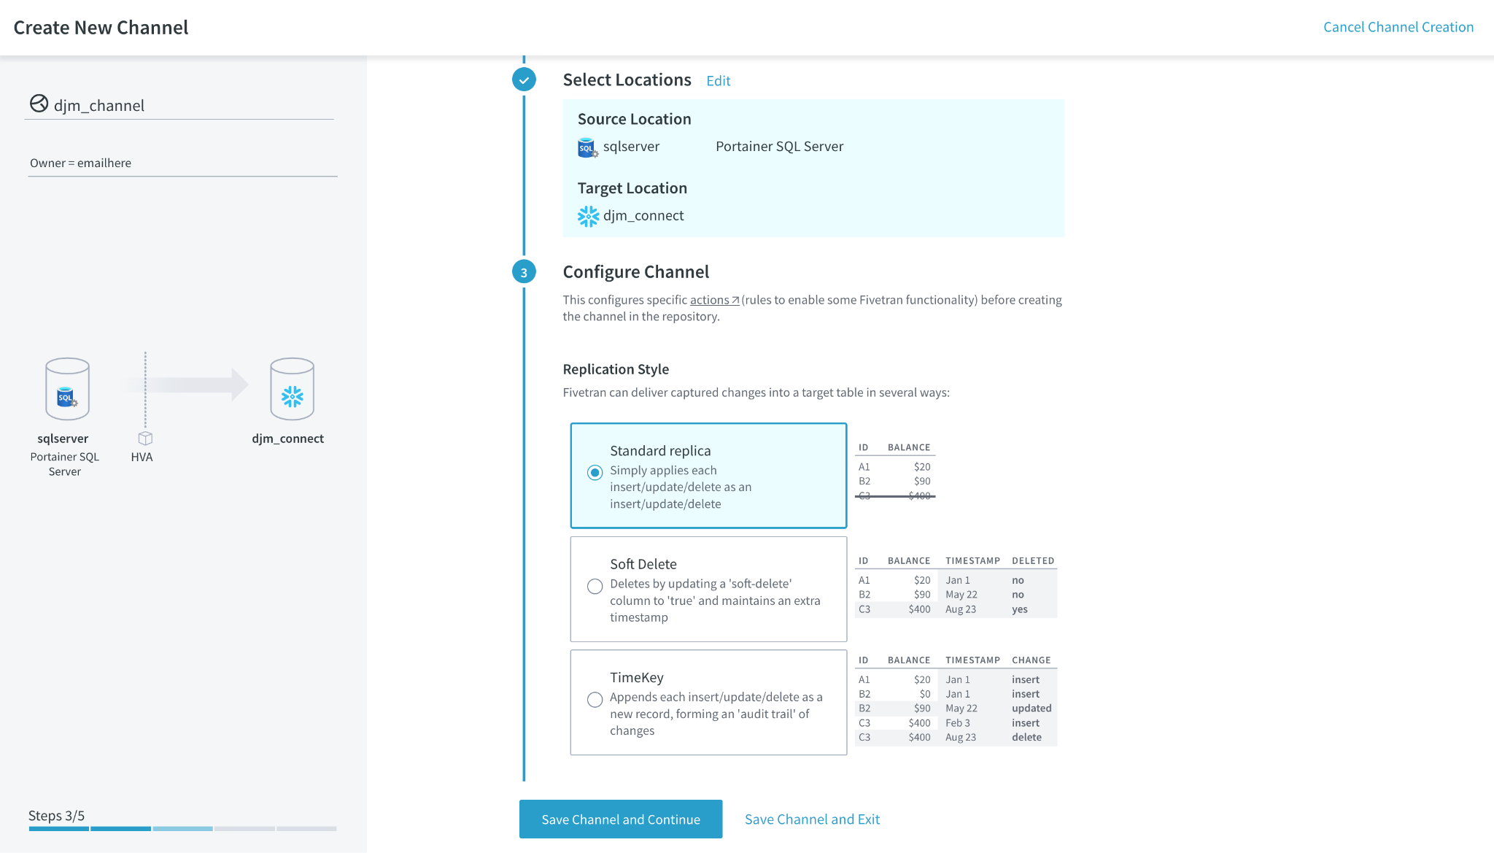

1. Step 4 is to **Select Tables to Replicate** and 

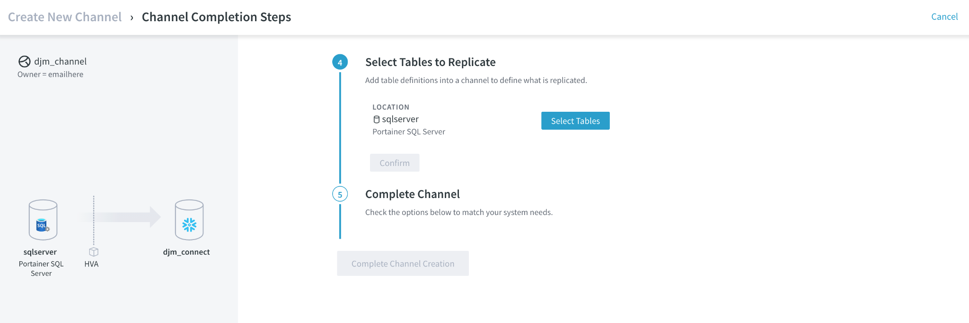

1. The list of tables that are available to replicate are listed. In a production environment all the tables should be replicated, but for this exercise select the following:
   1. **Customer**
   2. **Item**
   3. **Order_line**
   4. **Orders**
2. Press 

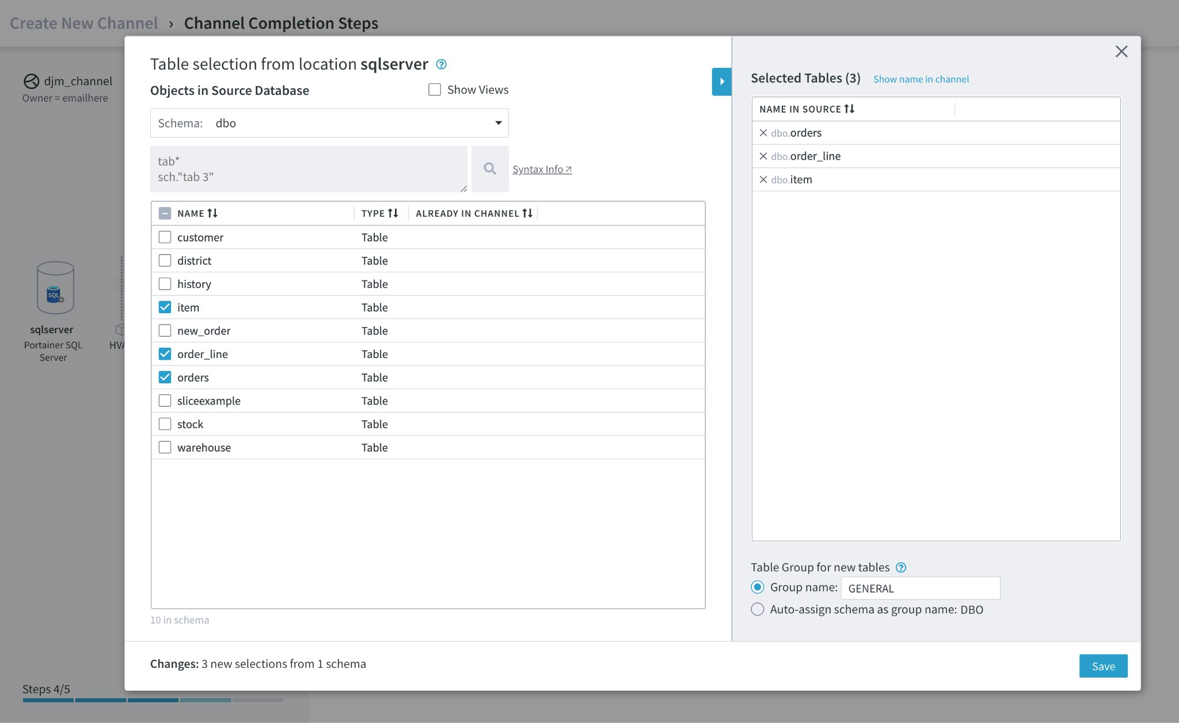

1. With the tables selected, they need to be confirmed, press 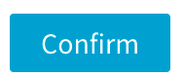

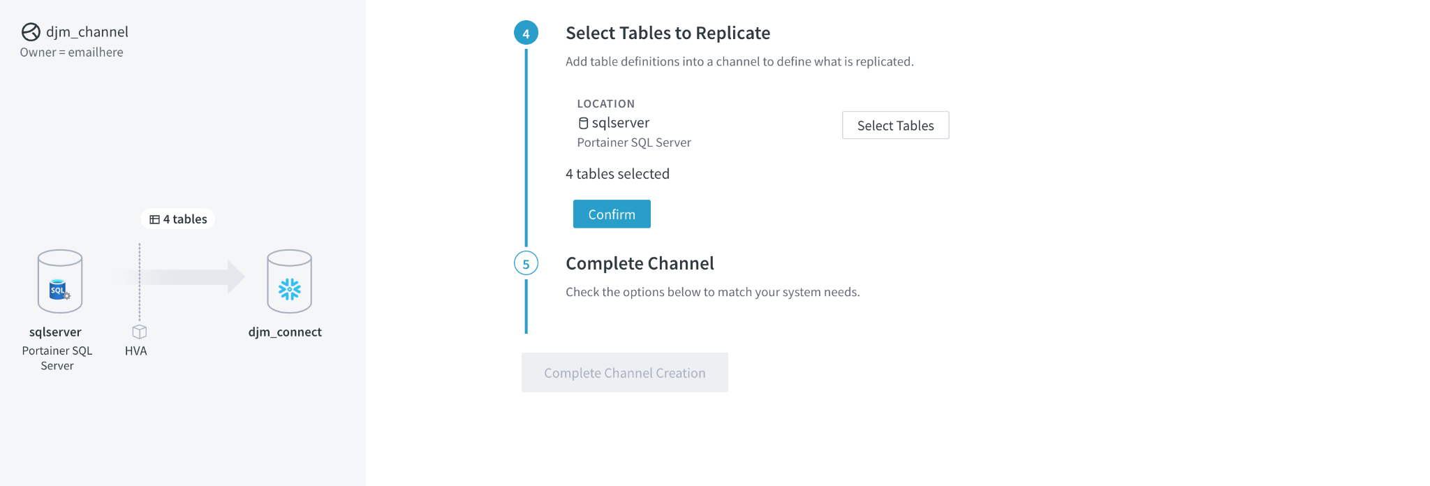

1. The channel is now defined and now needs to be started. The default selections will be used, press 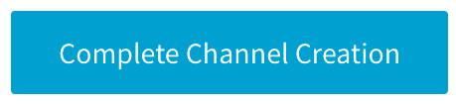

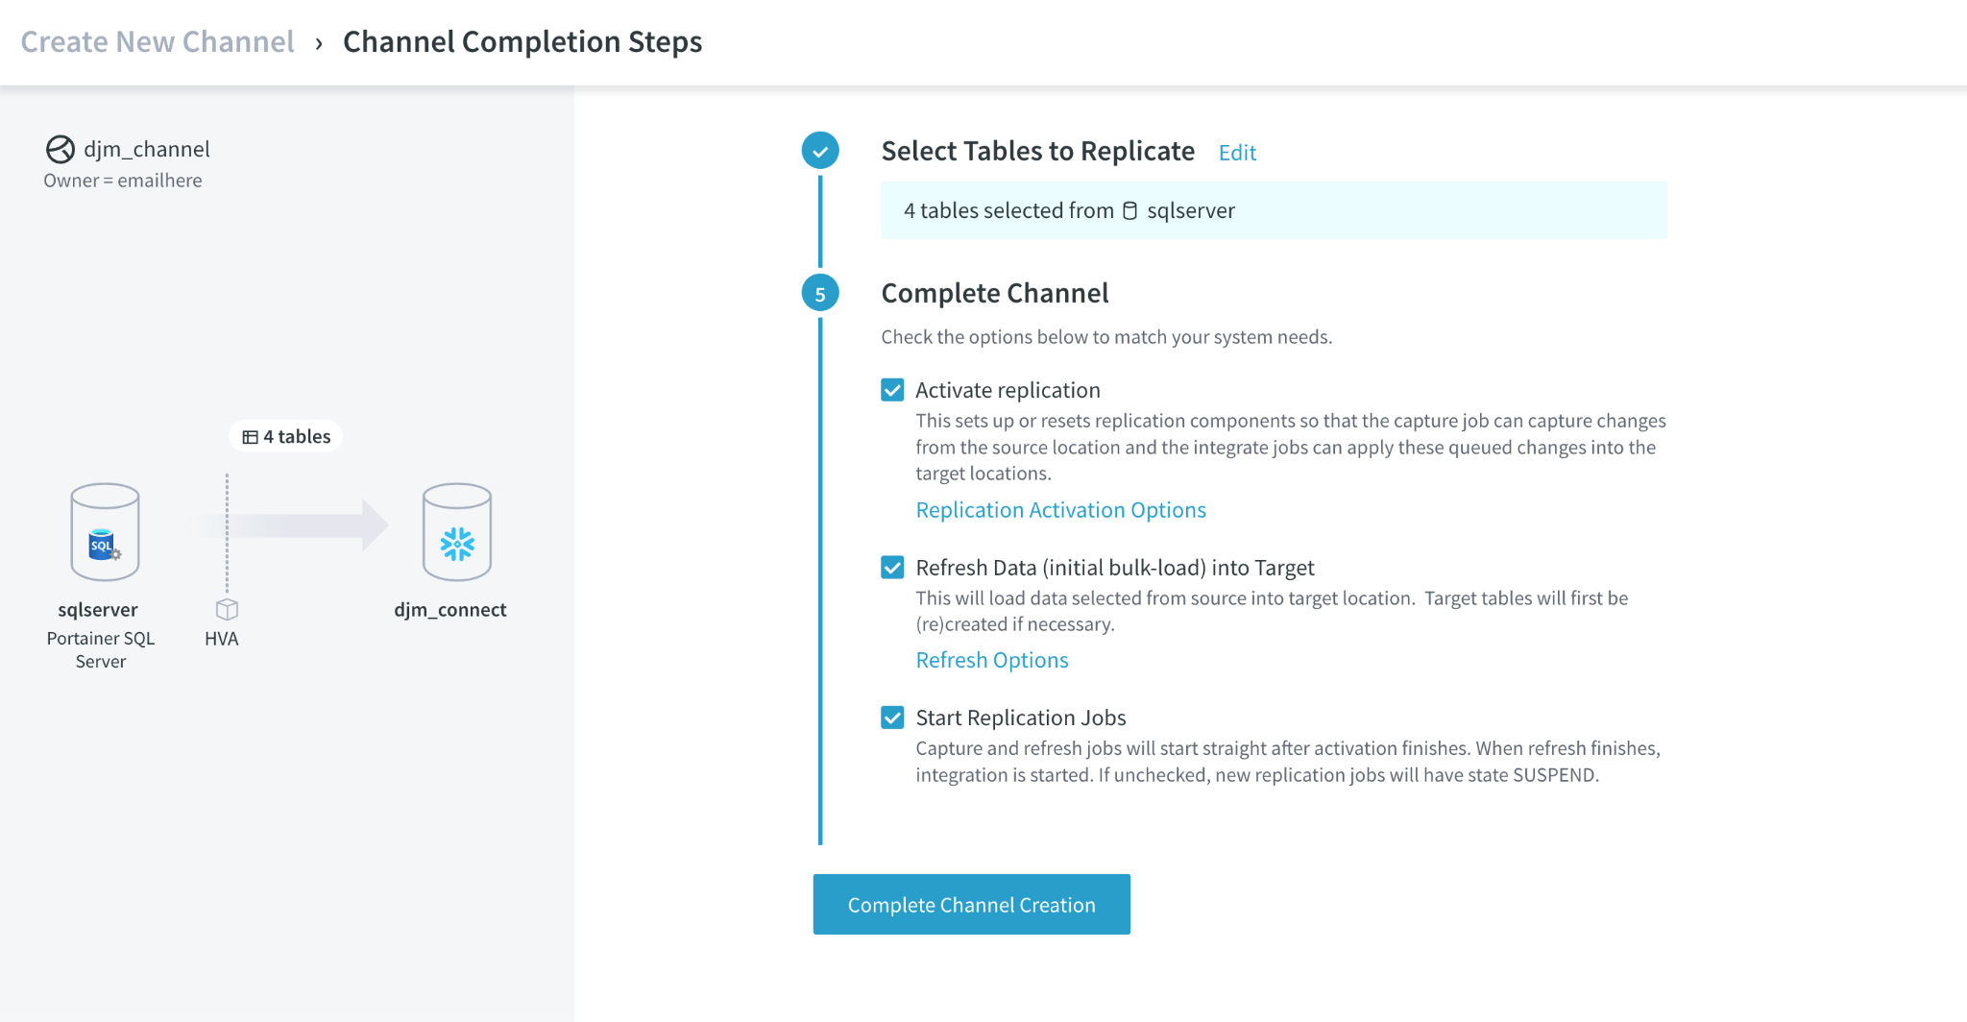

1. At this point the channel is created and running. The following screen displays the jobs and their state. The first job is ‘Activation’, where all the initial processes are created and started.

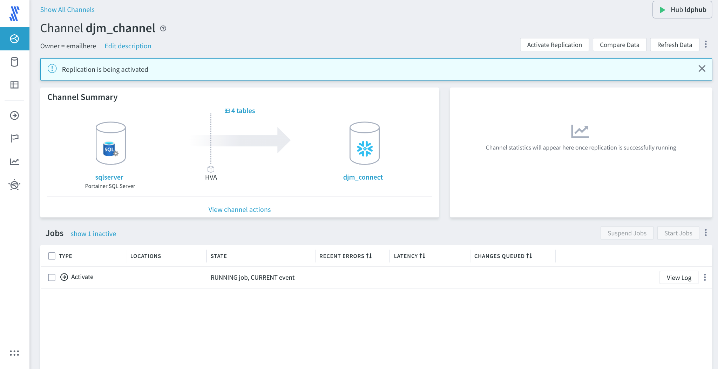

1. Activation finishes and the ‘Refresh’ job now starts, by creating the tables and moving the initial data to the target. Note that the ‘Capture’ job is also running. At this stage, the ‘Capture’ job is listening for changes and saving them to the LDP Hub. Note that the ‘Integrate’ process during ‘Refresh’ is Suspended. No changes will be propagated to the target until the refresh is complete. This is very important for data consistency.

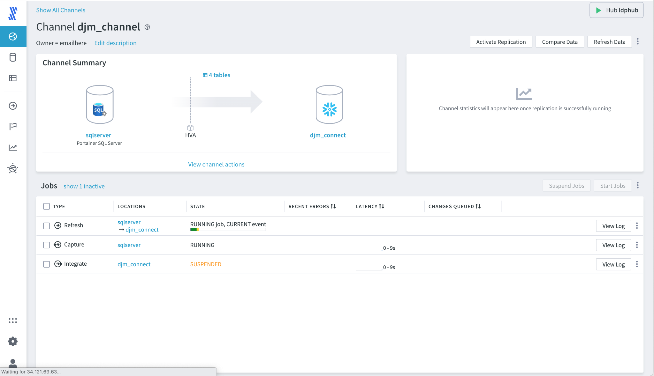

1. When the ‘Refresh’ job completes, the ‘Integrate’ job will automatically start.

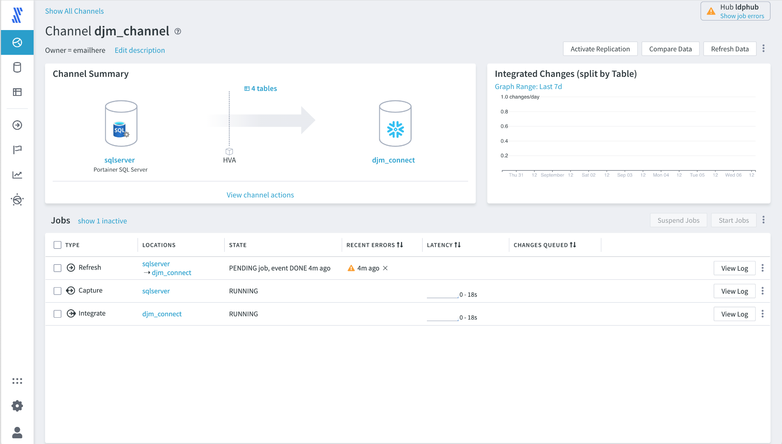

1. With any deployment, especially at the beginning of the configuration, there might be errors or warnings. Errors and warnings related to a specific job are shown in the ‘Recent Errors’ column and can be cleared by pressing (x) in the same column. However, it is best to see what has caused the errors. To see the errors, select 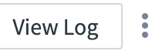 for the job to display the log.

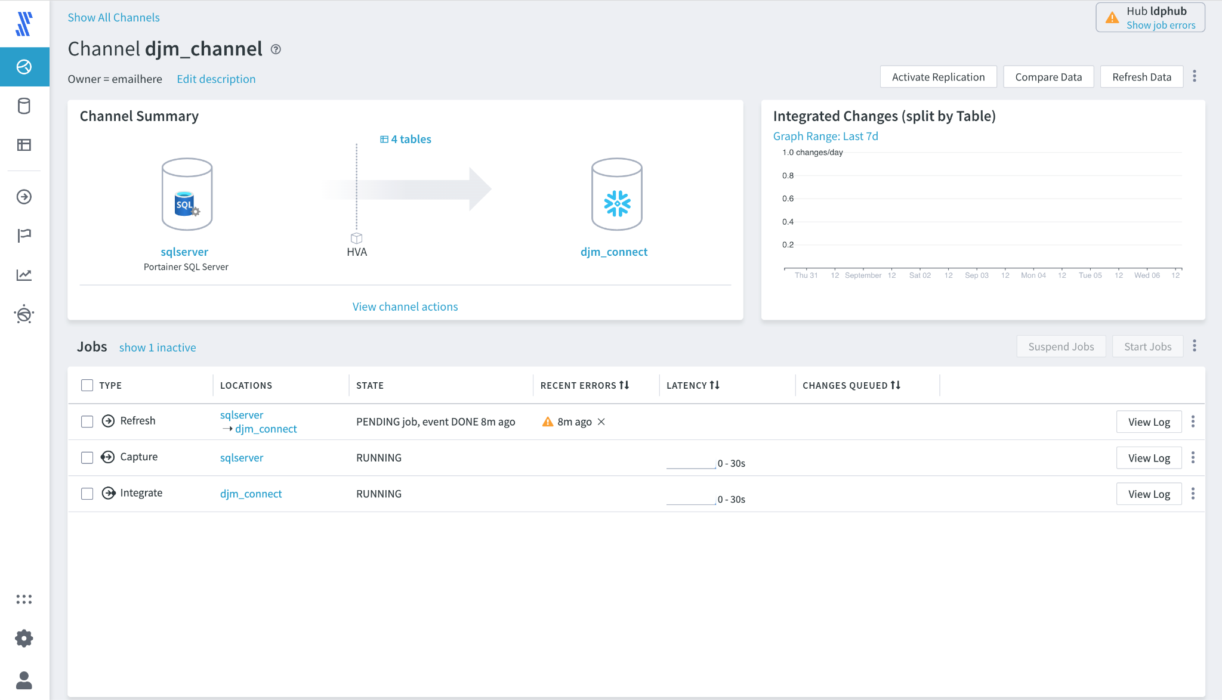

1. This shows the associated log file with the job in time order. Specific events can be searched using the Search bar at the top right, press the [x] at the top right to close the log and return to the ‘Jobs’ page. **Note:** If multiple log files have been viewed they will appear as separate tabs within the log viewer.

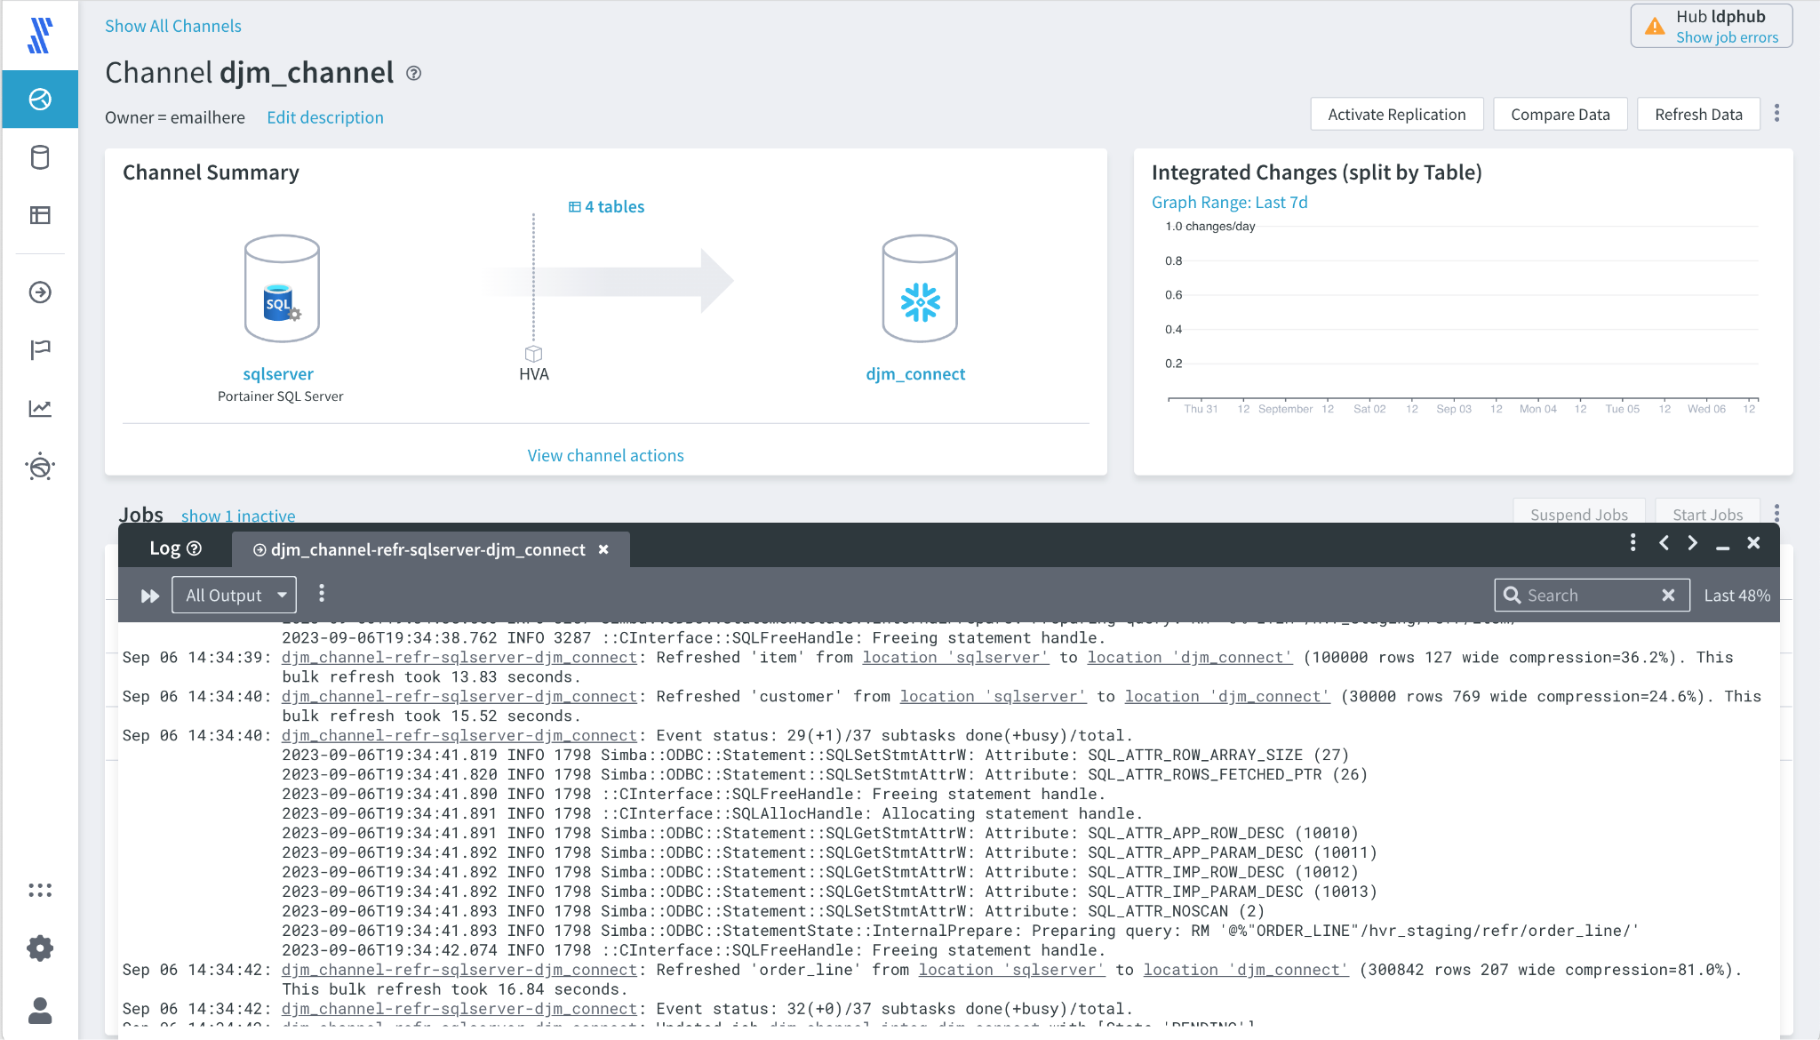

## 

## 4.5 Compare and Repair

An important capability within LDP is the ability to compare data in the source and destination. This can be done using the 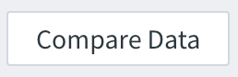 functionality, associated with rerunning refresh, using 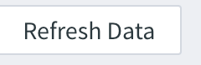 with specific options to optimize repair and make sure that all the data is accurate.

The structure of the lab is as follows:

* 4.51 - Ensure the Initial Load is Correct - run compare on the newly created Channel and validate the initial load is correct
* 4.5.2 Review Data in Database, Delete and Repair - perform some deletions on the target dataset, to introduce a scenario where data will have to be repaired.

### 4.5.1 - Ensure the Initial Load is Correct

1. Press 

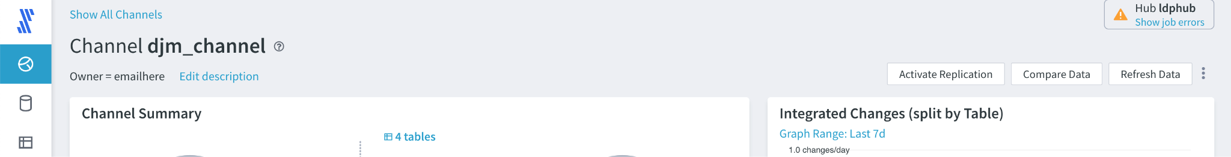

1. Various options are available on Compare, based on the scenario. By default it selects the most obvious ones that can be run i.e. compare all the tables, as shown next. If you believe only a few tables may be corrupted, i.e. because a developer has run an unexpected SQL DELETE on a specified table, then it is possible to limit the tables to run the compare. Note that Compare does not stop or pause either the **Capture** or **Integrate** processes so can be run at any time. It will review the data in both the source and the destination as well as the LDP Hub, to validate that everything is identical. Press 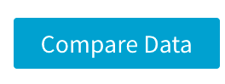

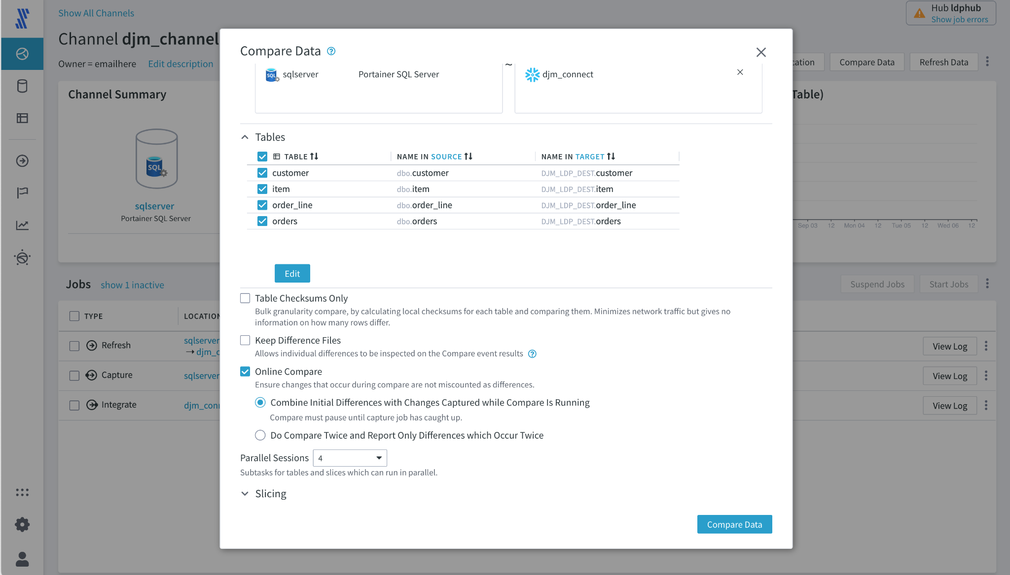

1. ,In the Jobs section of the page, a Compare job will start, if there are any errors please review in the log and then clear.
2. 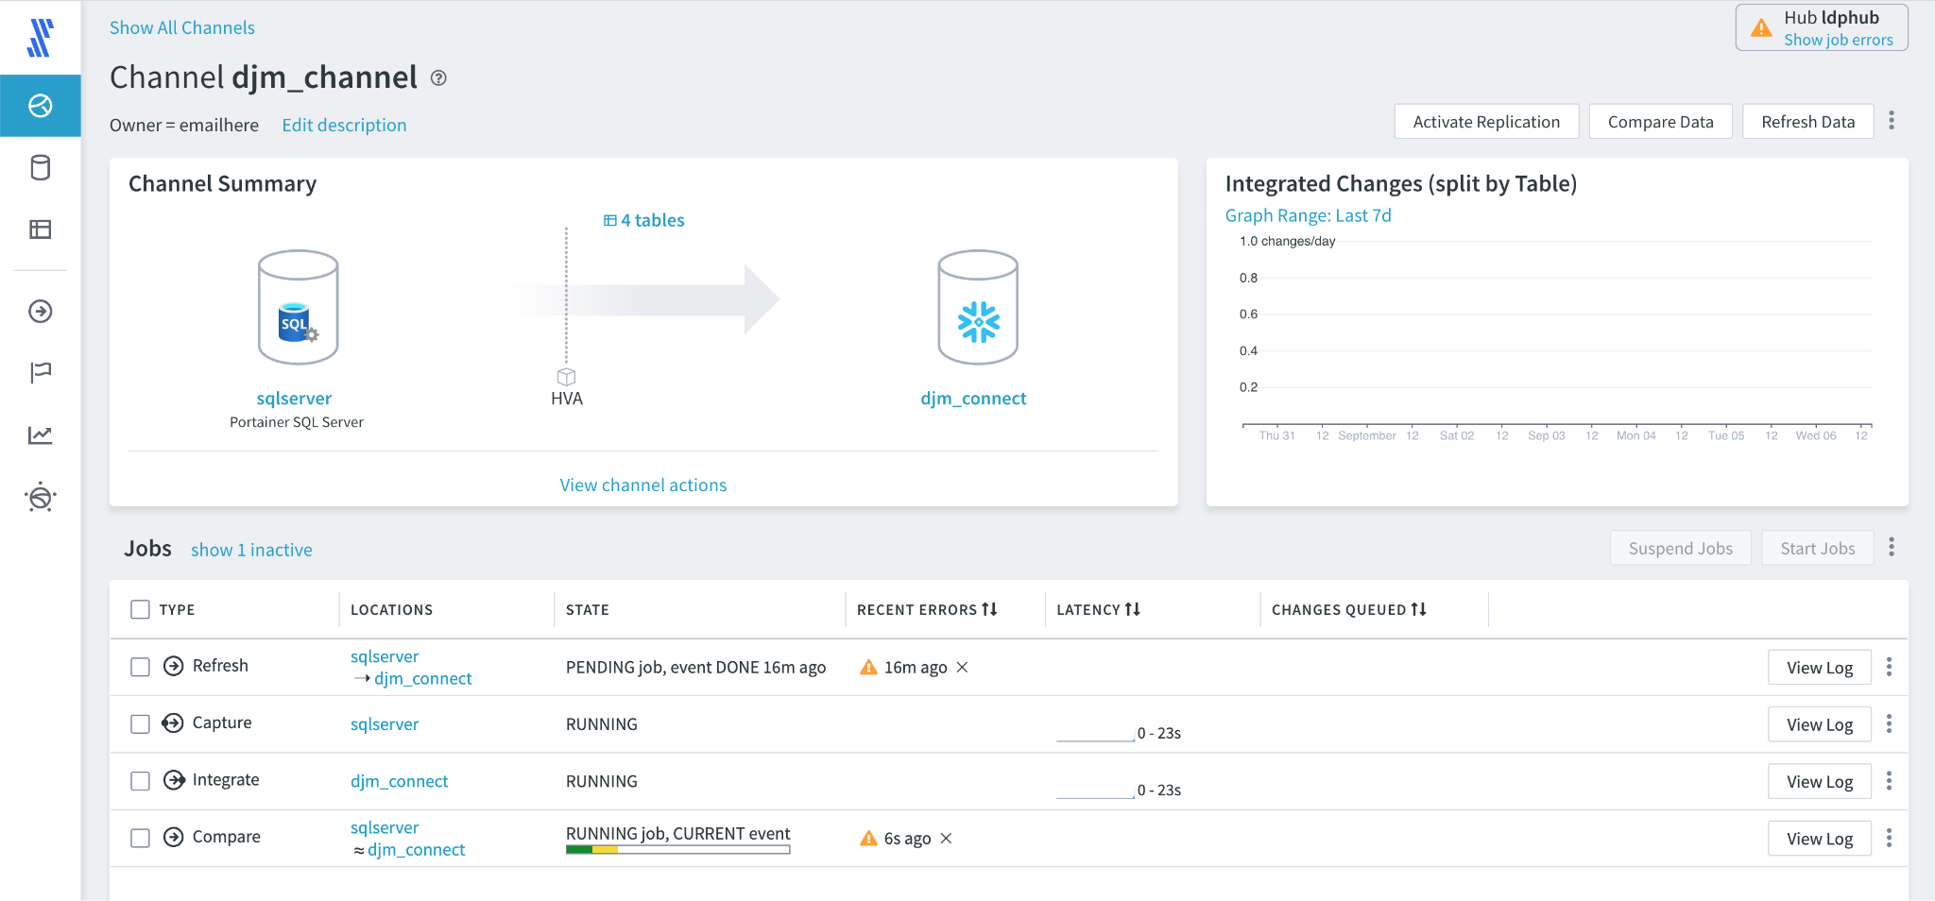
3. When the Job is complete click on the dots to the right of the View Log button and select ‘Go to Event’, this will cause the output of the job to be displayed.

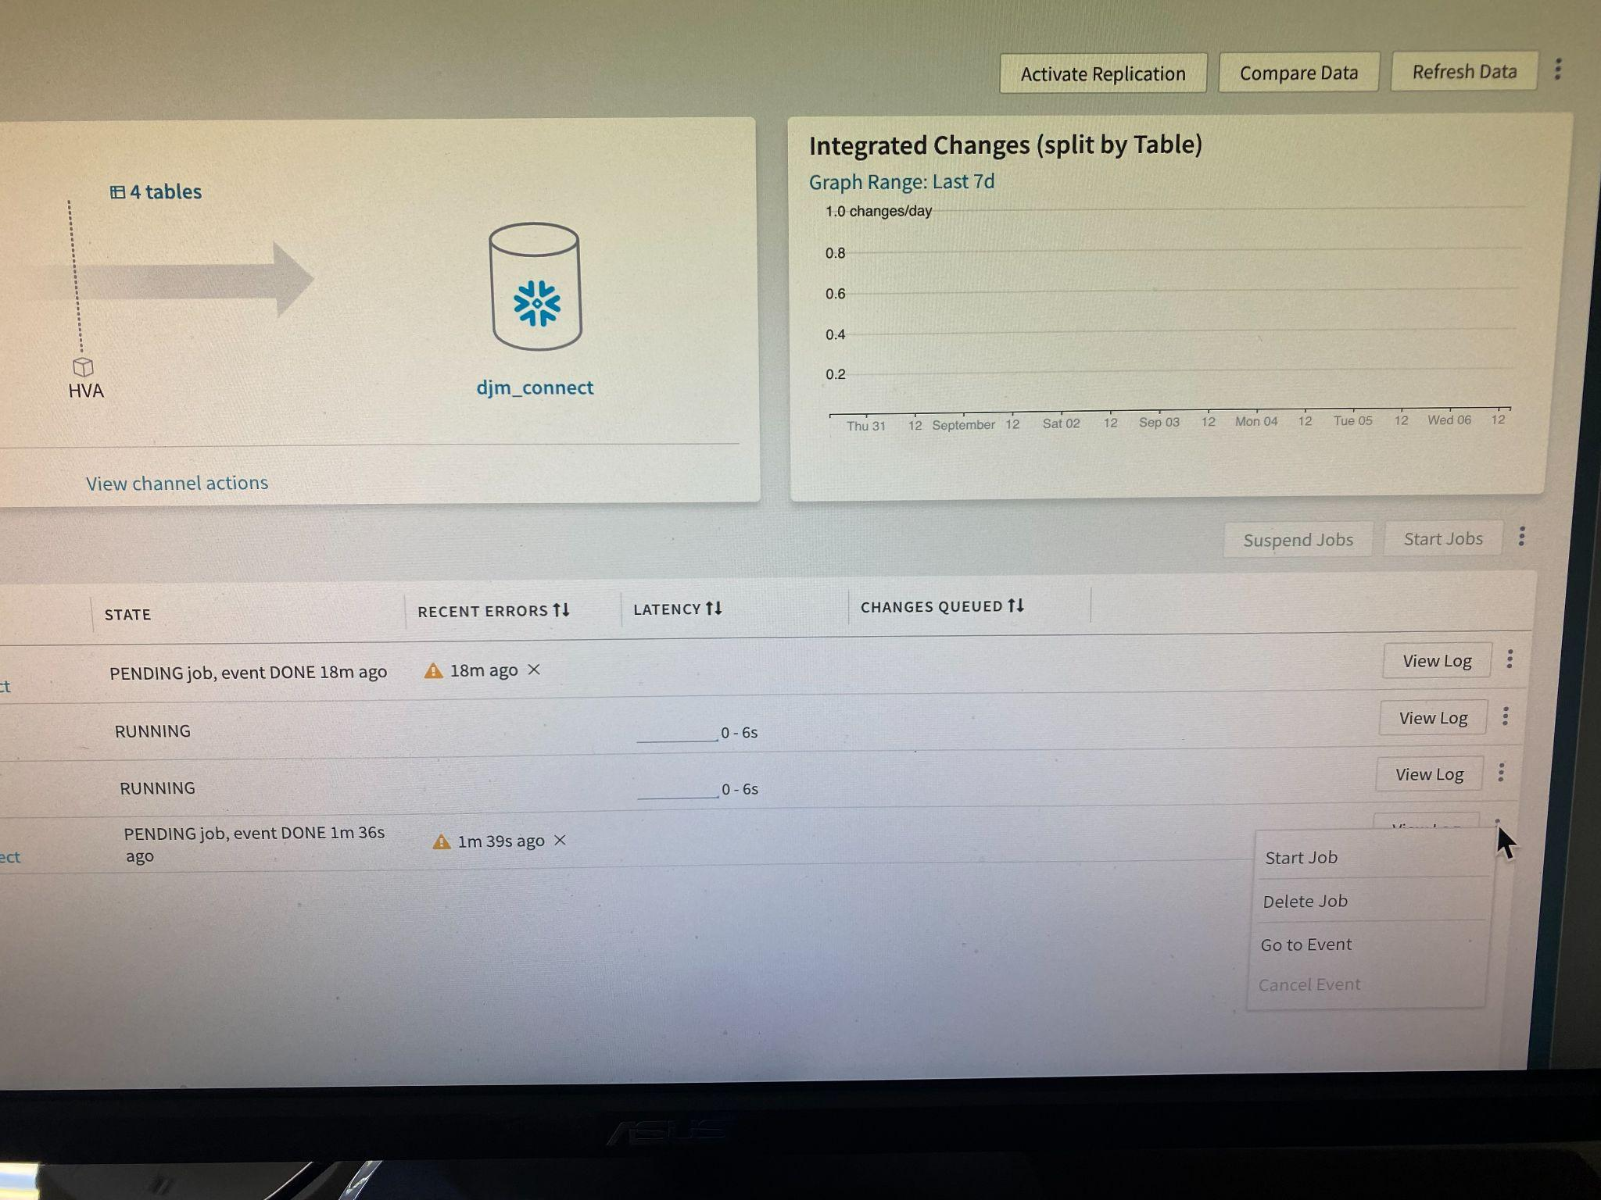

1. The results of the compare job are now displayed to the user, at this point it is expected that the source and the target will be the same. Here all the tables are listed and it is important that the counts for each row in the columns Source Rows Used, Source Rows Selected and Target rows Selectedare identical.

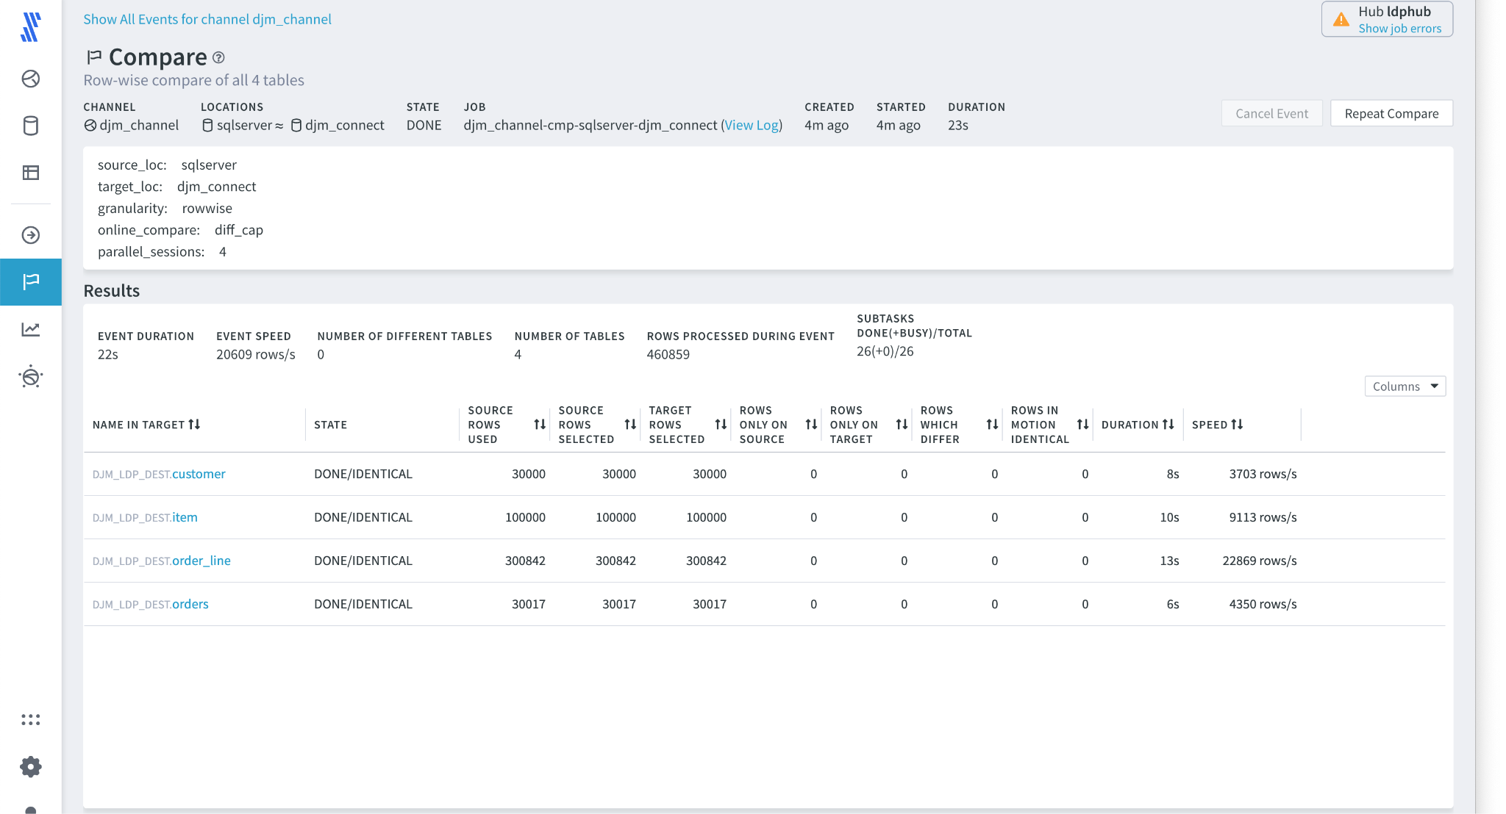

1. So far the jobs displayed have been in context of a particular channel, select the jobs option on the left and all the current will be displayed, assuming other attendees have successfully built pipelines these are now visible.

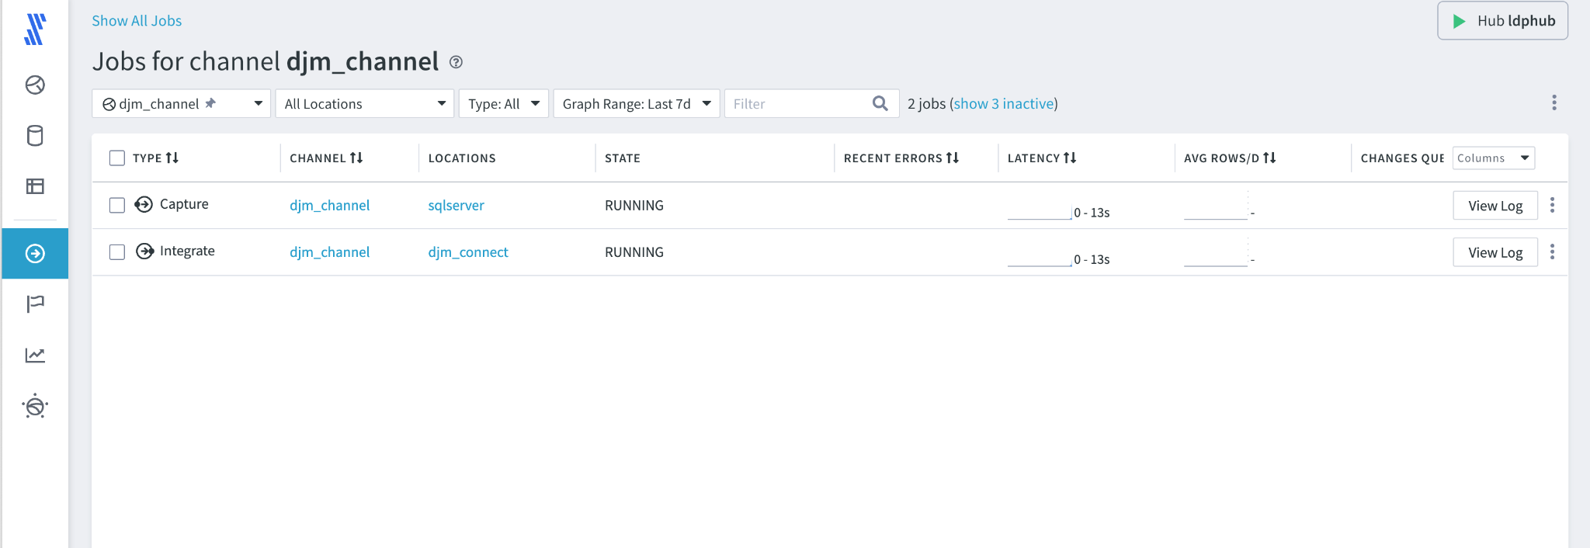

1. When a job is complete it is called an Event. Sometimes small discrete jobs like Compare can finish, and as they are not active they are removed from the Channel’s job page. Selecting the Events panel shows all the finished jobs and allows the user to find specific jobs that have just happened or may have happened a few minutes, hours, weeks ago.

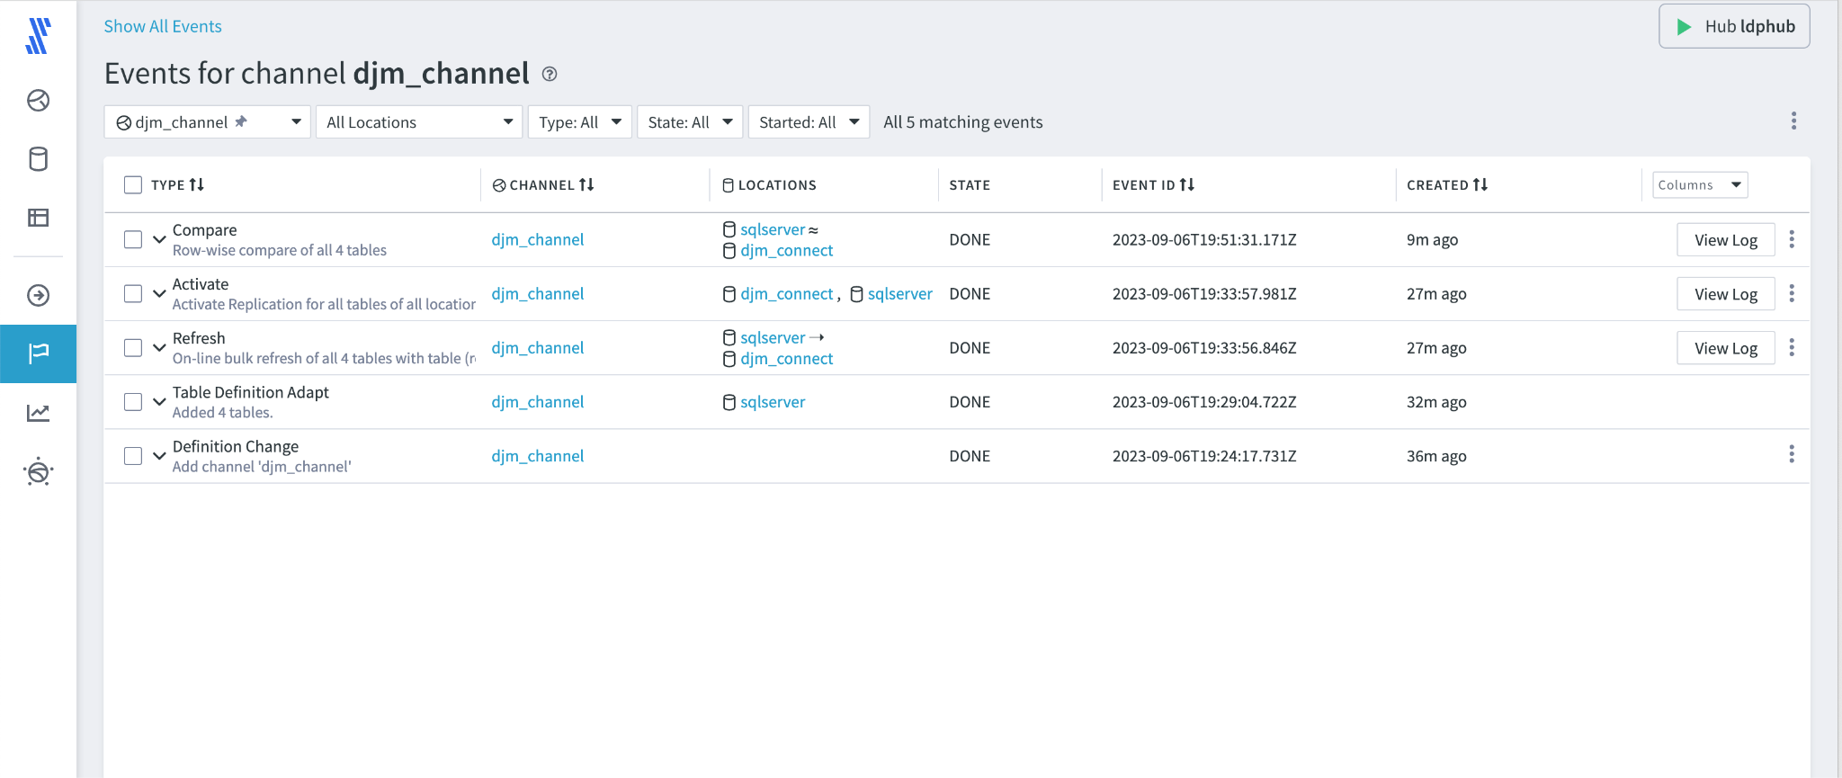

1. Statistics are also available and are constantly being read by the Hub. These are available in the Statistics setting.

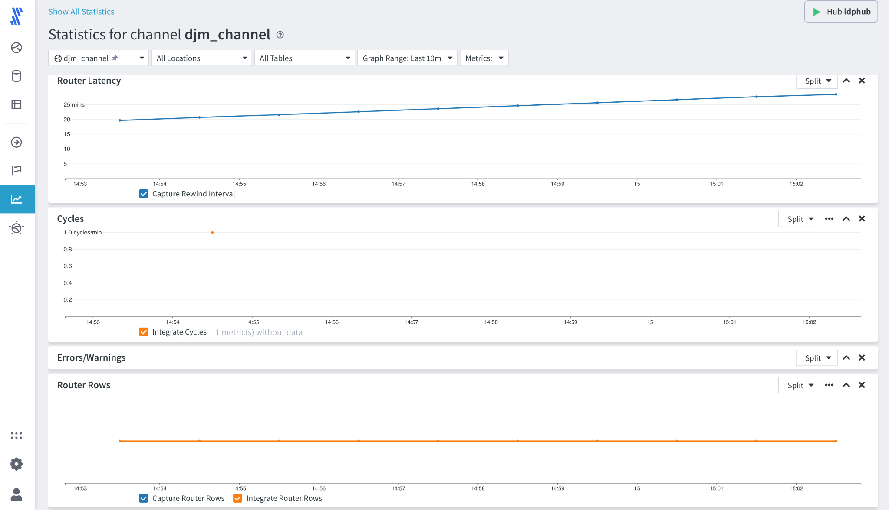

1. The final useful management view that is visited as part of this lab, is an interactive image of all the channels that are configured. Unlike previous views that have been very tabular, this shows all the channels that are configured as part of the hub. This is achieved by selecting the Hub view, each channel is a line or multiple lines based on the selected channel topology. Relative metrics are shown through thickness, and capture/integrate metrics can be reviewed by selecting the relevant (X) on the line, where the metrics are displayed on the edge.

### 4.5.2 Review Data in Database, Delete and Repair

Having reviewed the functionality when everything works as expected, we are going to perform a quick exercise to demonstrate how to fix errors in the data.

1. Go back to Snowflake and review the Schema that was created for the LDP destination, then list all the tables. There are few things to note, the expected tables Customer, Item, Orders, and Order_line are all there, but there are other tables as well. These tables named **HVR_** are working tables that LDP places data in to ensure data consistency when performing upserts and the like. These tables are automatically updated, deleted, and modified by the Hub and the **Integrate** process.  
     
   There are options to place the working tables and the final usable tables in separate Schemas, but that is beyond the scope of this exercise.

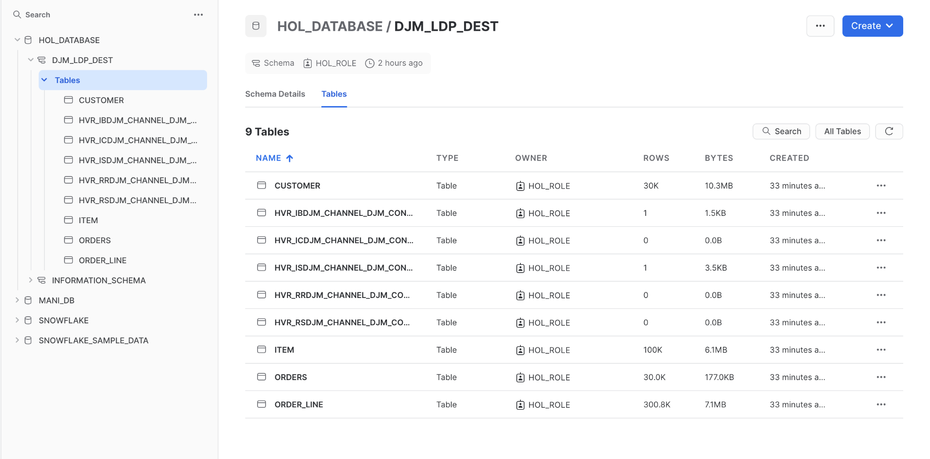

1. Select the tables view and specifically the Customer table

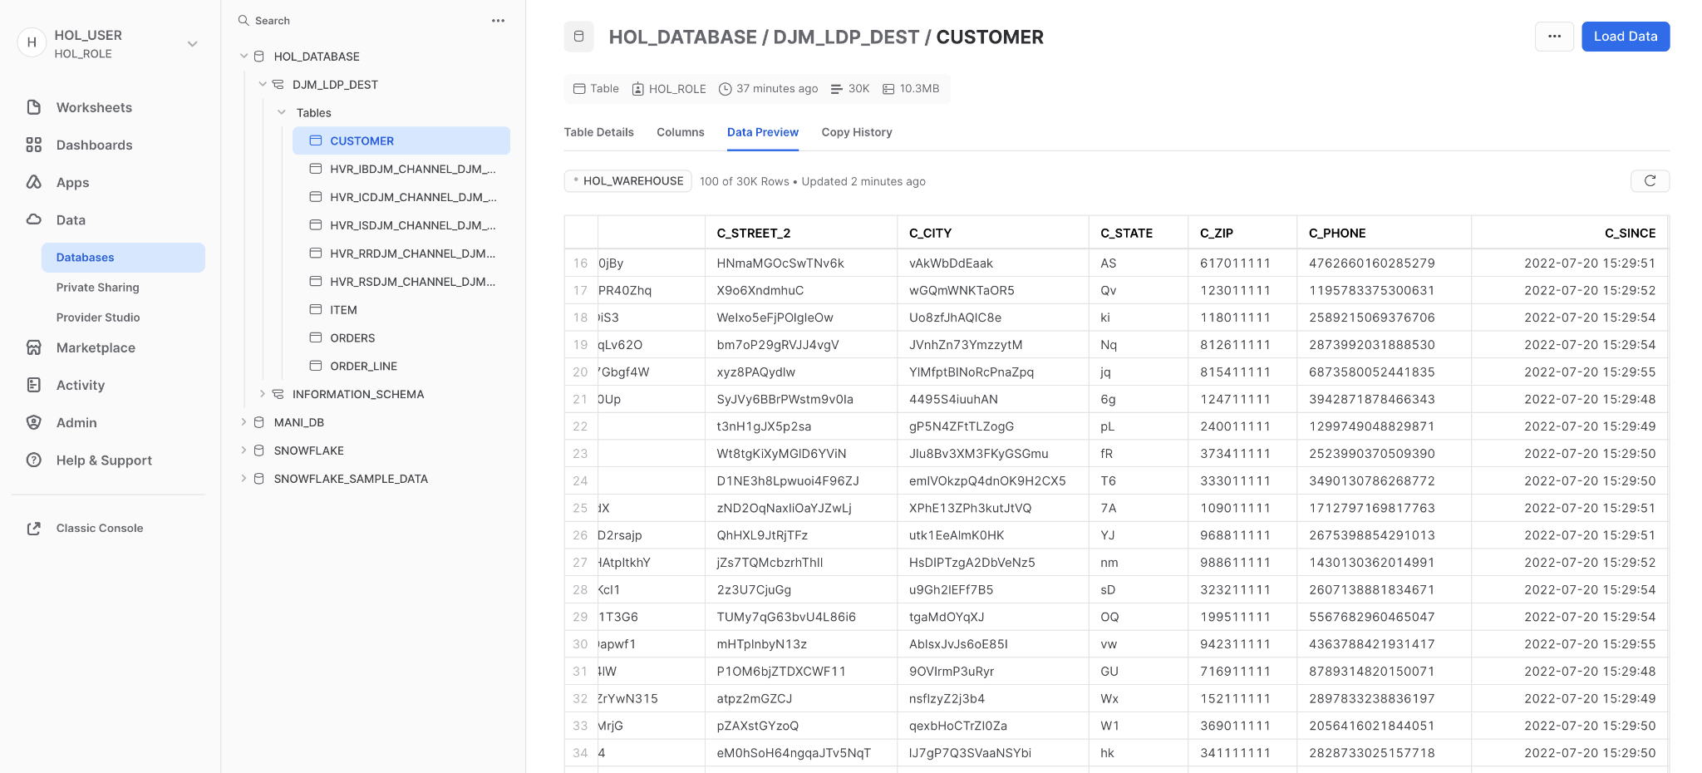

1. Create a worksheet that connects to the database and your specific schema **[cell-AQ]**

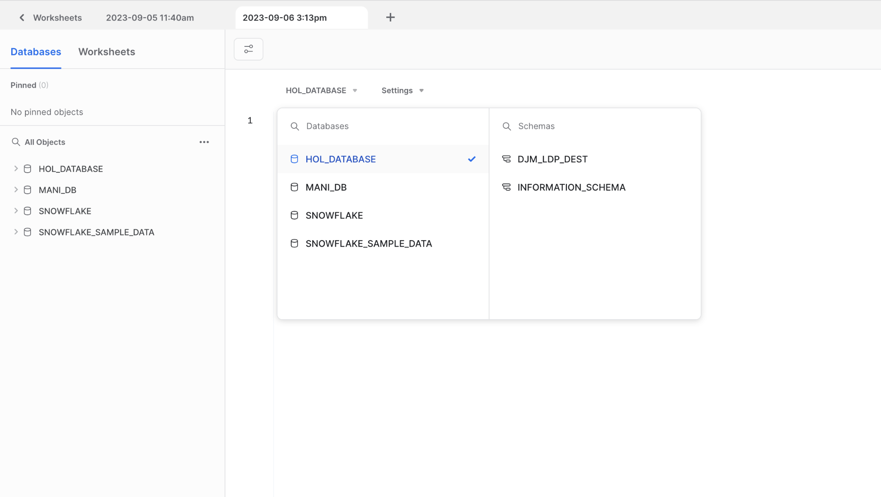

1. Within the worksheet execute the following SQL statements

|  |  |  |
| --- | --- | --- |
|  |  |  |
| 1 | select count(*) from Customer; | Returns a count of all the customers, this should be the same as seen in the Compare function |
| 2 | select count(distinct(c_state)) from CUSTOMER | Returns the number of distinct states (c_state) values used |
| 3 | select distinct(c_state) from CUSTOMER order by c_state; | Returns a list of all the states used, note that there should be one state called **1A** |
| 4 | delete from CUSTOMER where C_STATE = '1A'; | Deletes all the customers in the table that are found in the state **1A.** This should return the number of records that have been deleted |
| 5 | select count(*) from Customer; | Returns the count of all the customers that remain. The goal is that it is different from the count in SQL #1 above. |

1. Return back to the channel and select 

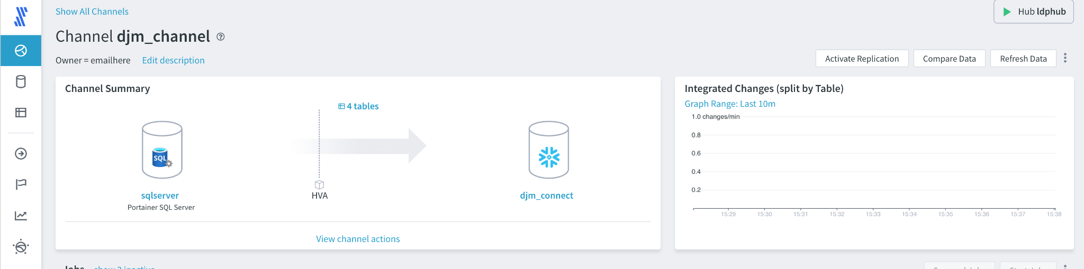

1. The Compare Data options are now displayed, same as before. Leaving everything else as the default, select **Keep Difference Files** as shown. This will keep a record of the individual records that are different.

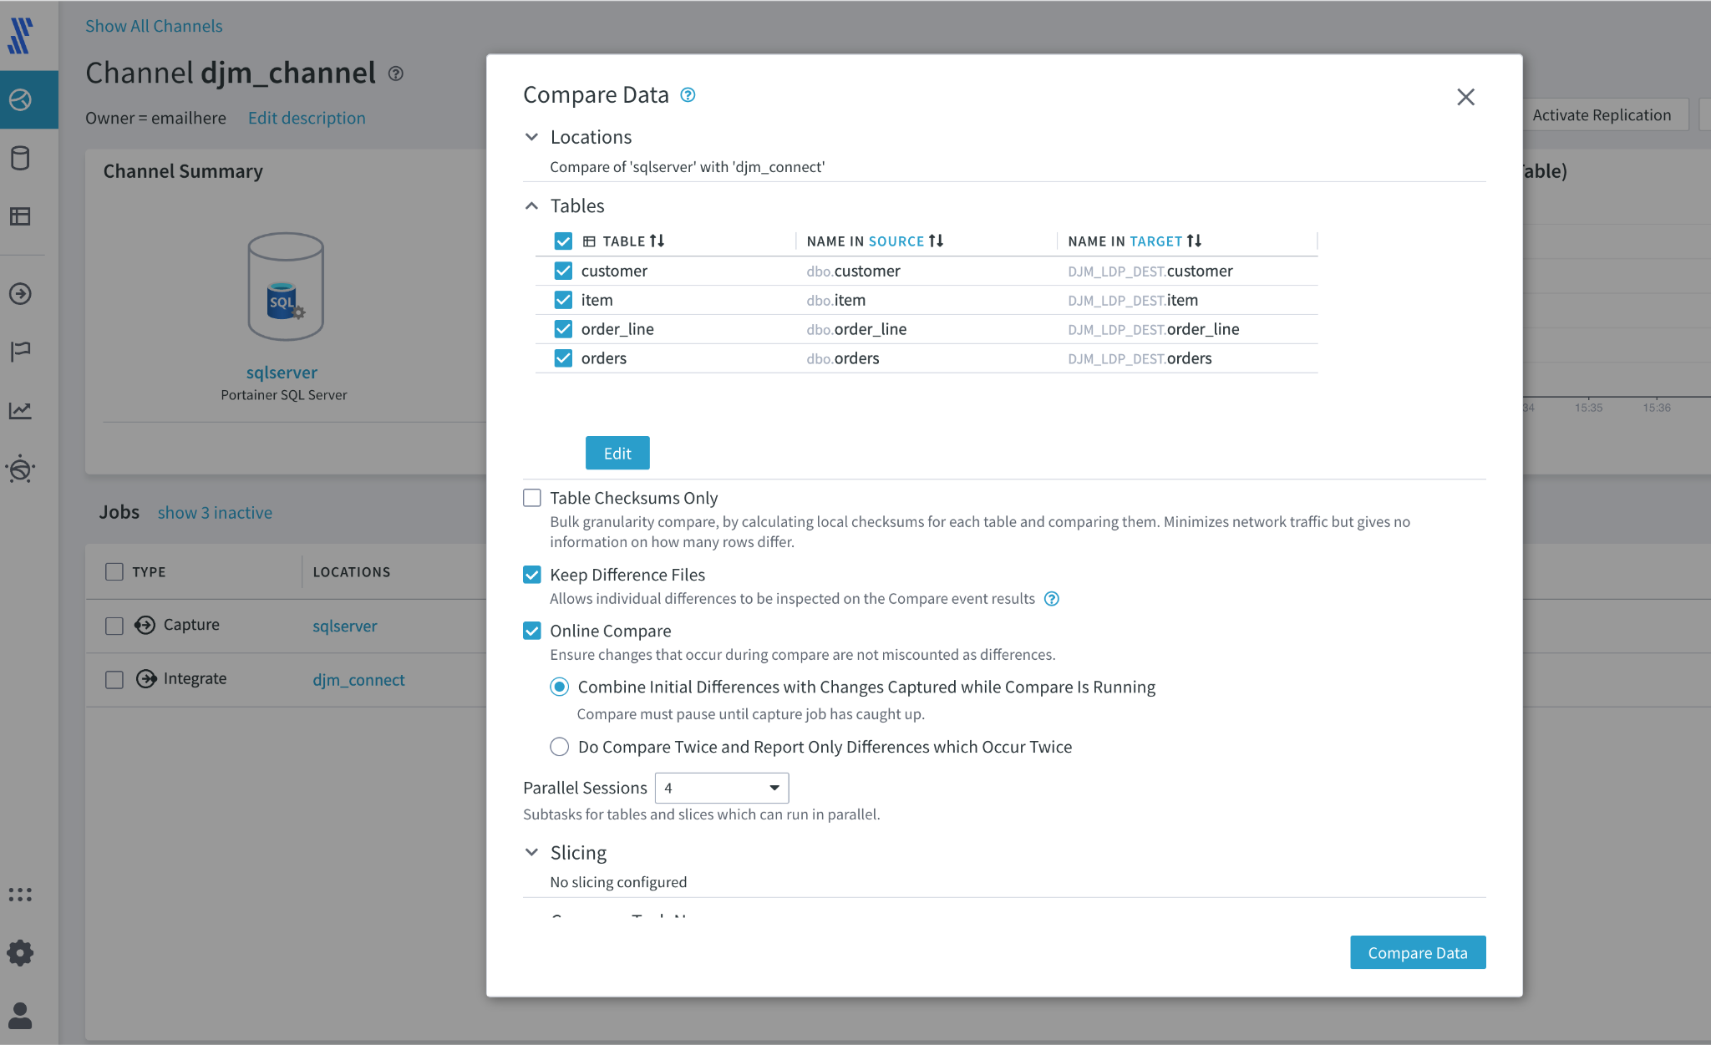

1. Press  and the Compare Job will be started

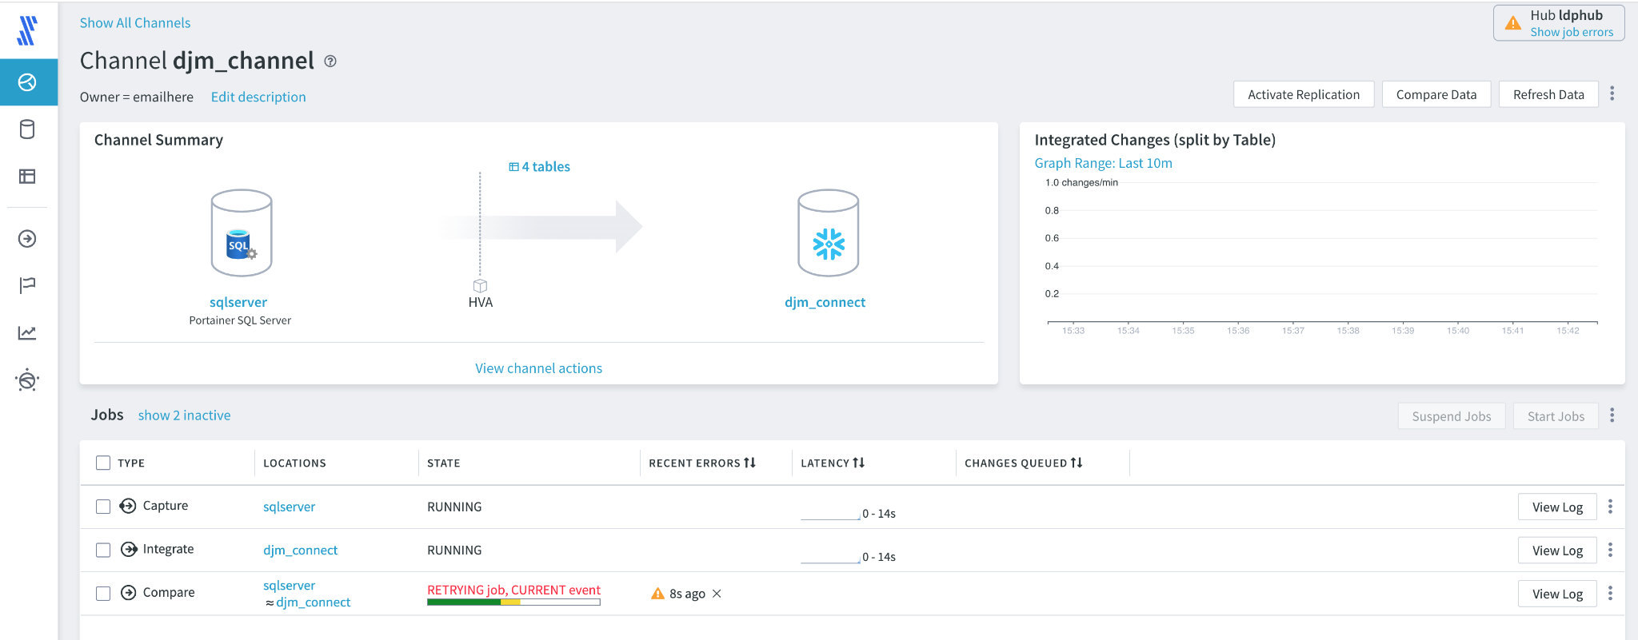

1. When the Compare Job is complete, click on the 3 dots to the right of the View Log Button, select View Event



1. The tables will now be listed, note the Customer table in a different color because differences have been found and highlighted. Also note how the option to create a Difference file has added a link in the Diff File column, called View File. press this link.

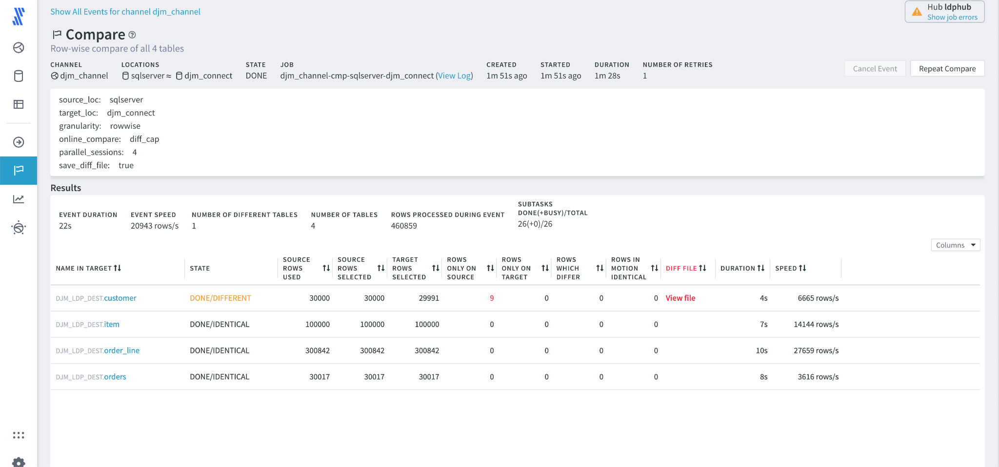

1. A dialog box appears, select Compare Differences

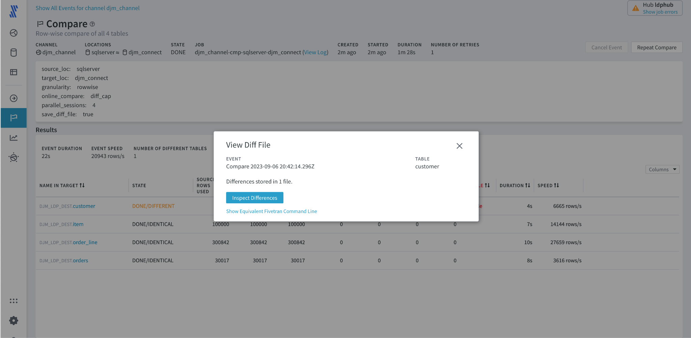

1. Each of the records in the difference file are shown, as this scenario shows files records that have been deleted, it shows a Green record for each row that is found in the source and not in the target. Note, target differences are normally shown as red and where possible LDP will match the source to the target.

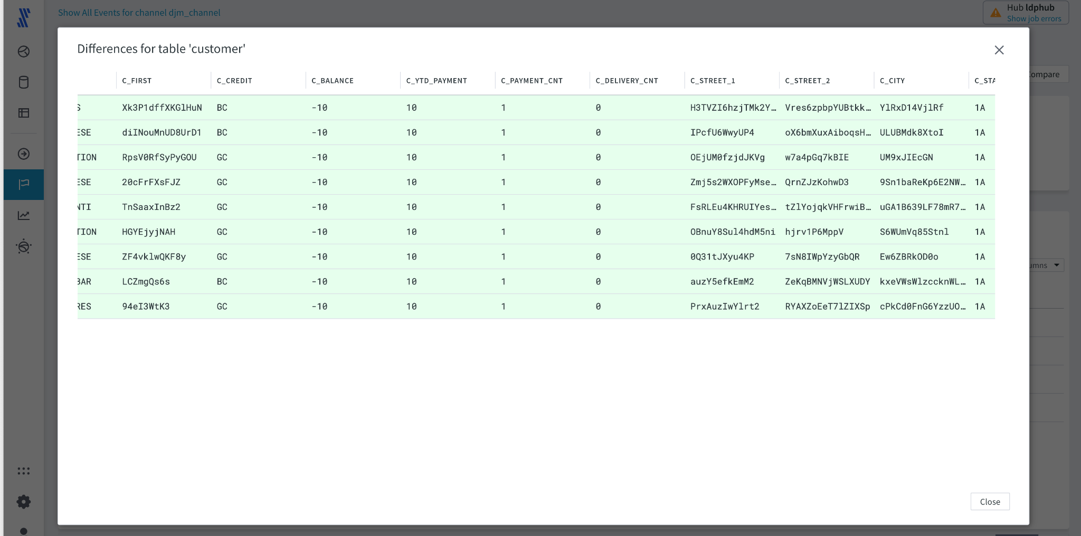

1. Once the changes have been observed and seen to be the same as those created in the SQL statements., the screen can be closed

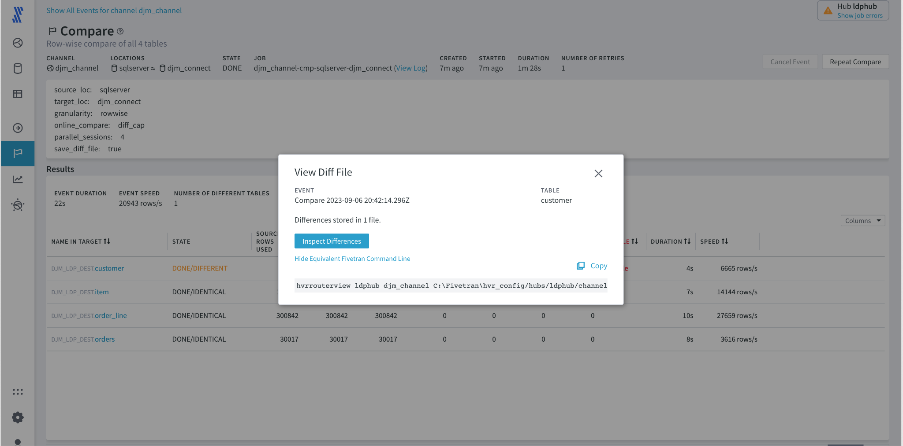

1. You are now returned to the channel, ready to start a refresh 

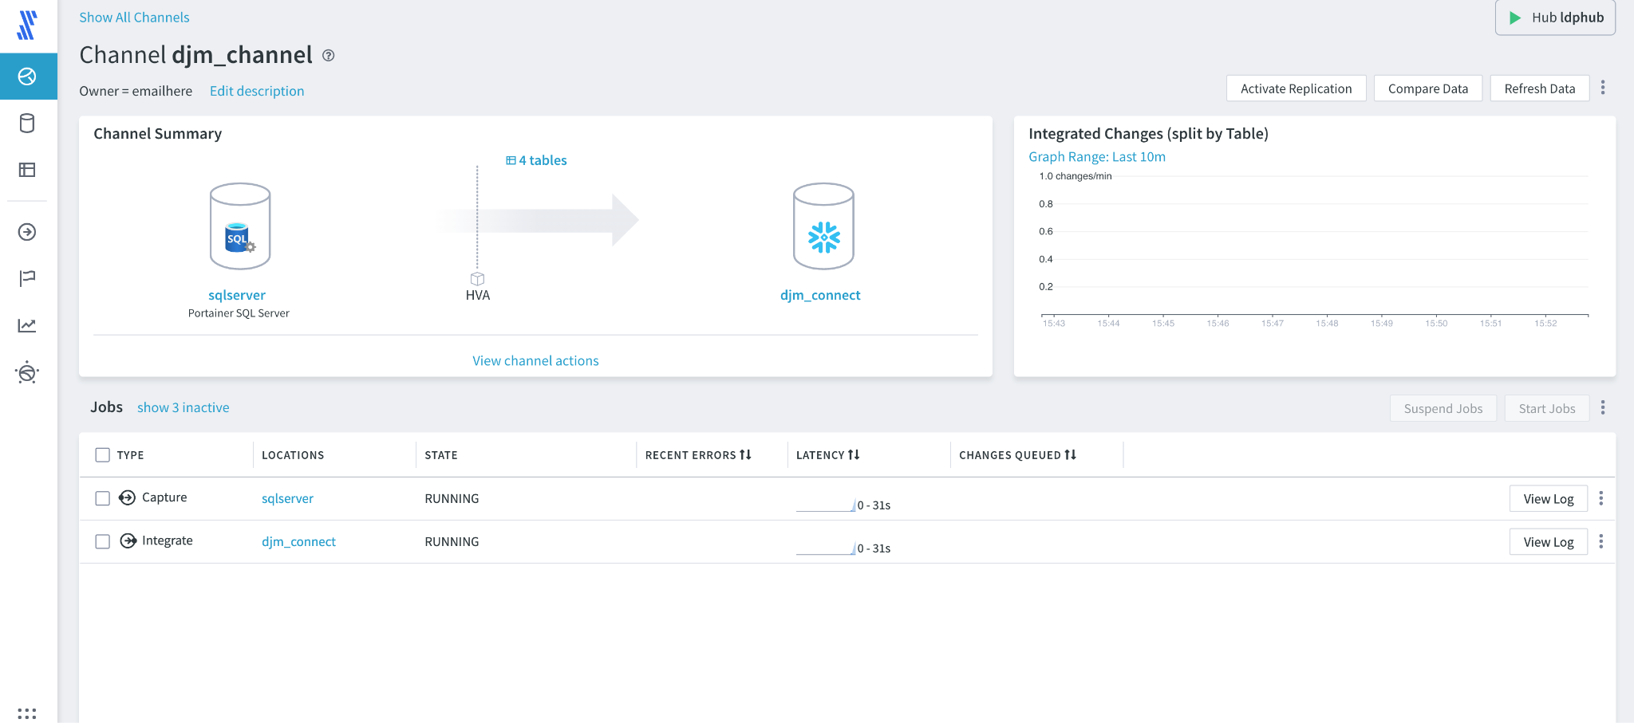

1. Options are now shown for the refresh, for repairing data either select **Bulk Load**, this will truncate the existing Customers table and reload the data from scratch. This can be quickest when large datasets need to be repaired. The other option is to **Repair** in this case individual records will be added, this can take longer, but disrupts the target database less.  
     
   Select **Bulk Load** and then Refresh Data.

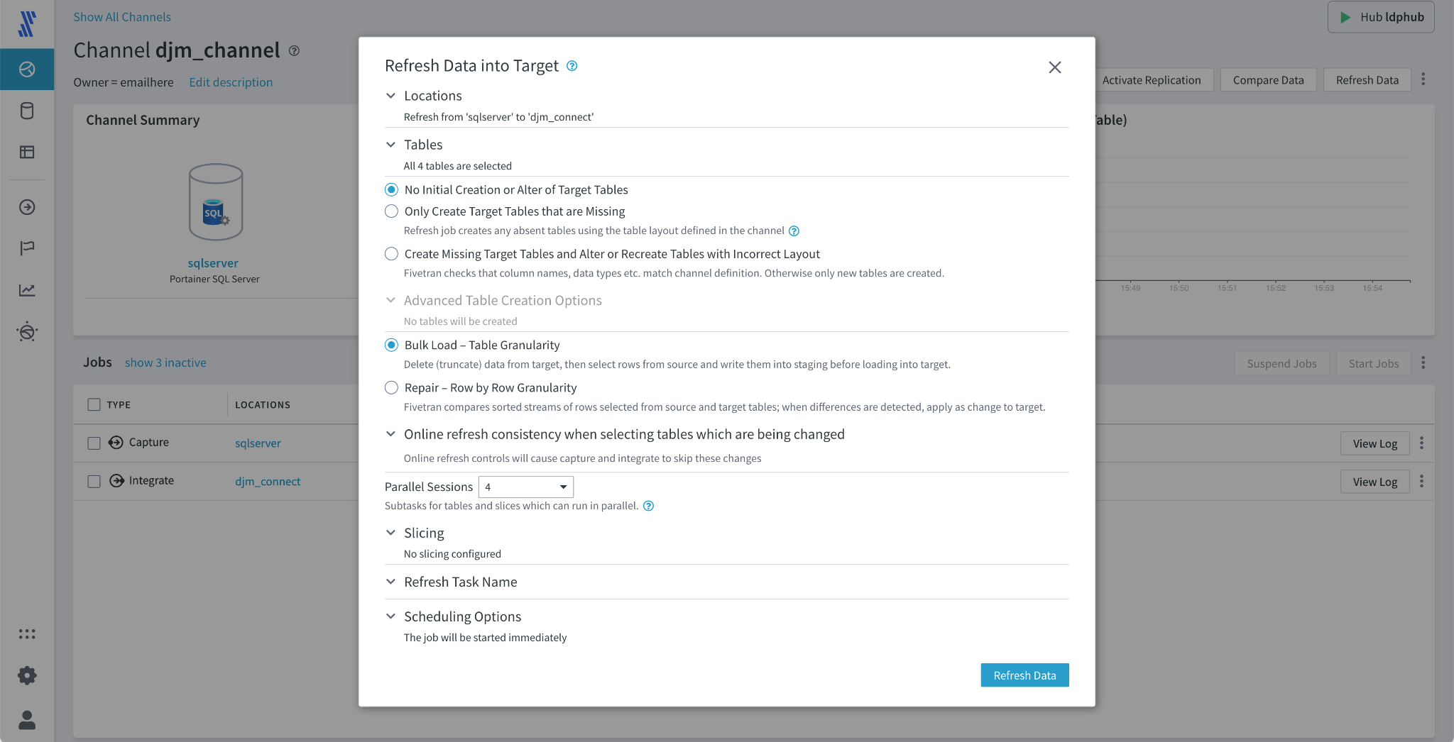

1. The Refresh job now starts.

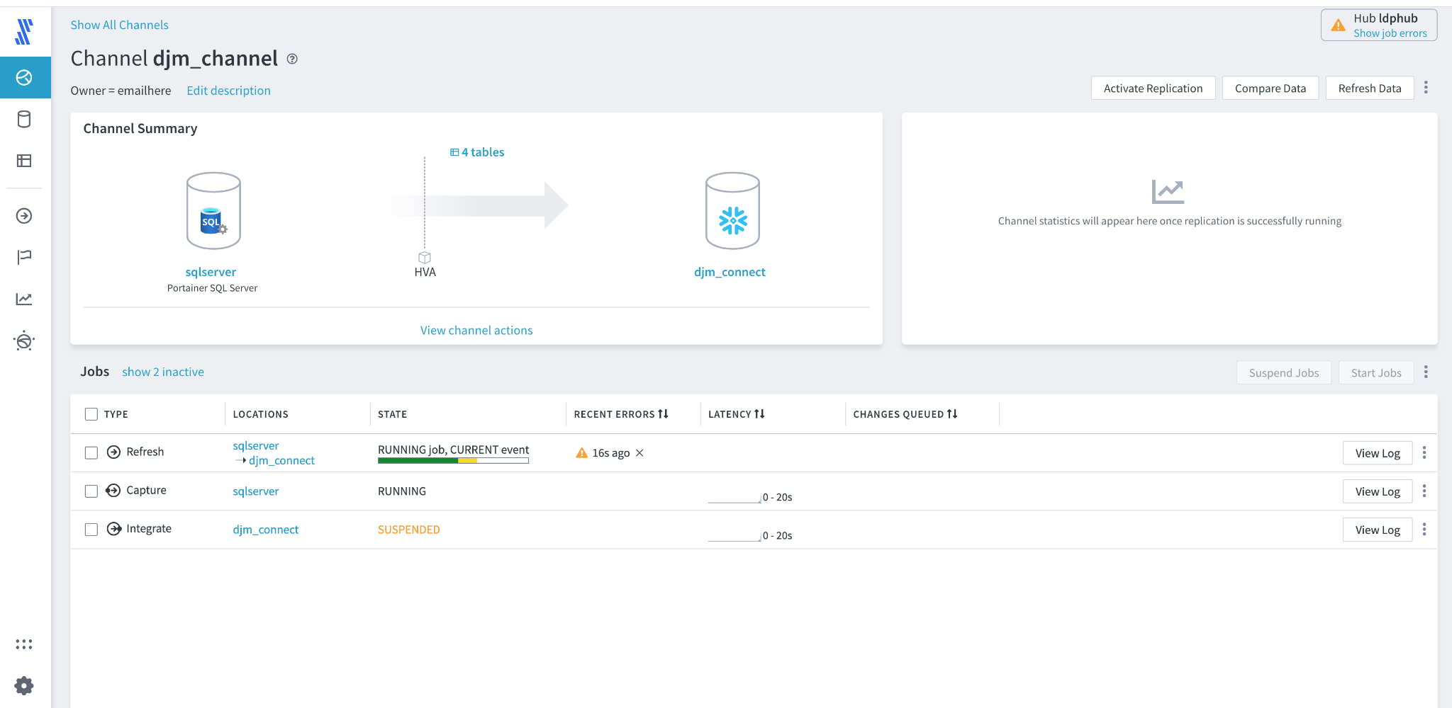

1. On Completion of the Refresh, select  and initiate a comparison job
2. Review the results and ensure that the source and destination are correct.



**Congratulations !!! You've completed the LDP lab, now login to Zinfi for the LDP certification test.** [**HERE**](https://fivetran.zinfi.net/concierge/ucm/#/ucm/1298/1108/v/17)

**Remember to have your copy of 100 Fivetran Facts close by**